Arrowhead_core_JD15_experimental

Requirements Table Diagram Report

Author: <Author name>

Revision: 0.1

|  |  |
| --- | --- |
| NA |  |
| NA | Date: February 14, 2021 |

**Revision History**

|  |  |  |  |
| --- | --- | --- | --- |
| **Revision** | **Date** | **Reason For Changes** | **Author** |
| 1.0 | Jan 02, 1990 | <Release> | <Author Name> |
| 0.1 | Jan 01, 1990 | <Initial draft> | <Author Name> |
|  |  |  |  |

**Table of Contents**

Microsoft Word users please click here and press F9 to create Table of Contents.

OpenOffice.org users please remove this text and select Insert Table of Content from menu.

**Table of Figures**

Microsoft Word users please click here and press F9 to create Table of Contents.

OpenOffice.org users please remove this text and select Insert Table of Content from menu.

**Executive Summary**

This section previews the main points of a report. The executive summary contains enough information for a reader to get familiarized with what is discussed in the full report without having to read it.

# Introduction

## Purpose

<This document provides requirements with their properties including requirement id, requirement name, requirement text and the dependencies.>

## Scope

<Provide a short description of the system being specified and its purpose, including relevant benefits, objectives, and goals.>

## Overview

<Describe what the document contains and explain how the document is organized>

# Requirements

| **ID** | **Name** | **Text** | **Requirement Type** | **Owner** | **Source** | **Risk** | **Verify Method** |
| --- | --- | --- | --- | --- | --- | --- | --- |
| 2 | -1256937164.jpg  System of systems Description - LocalCloud Design | The SoSD describes the main functionalities and the generic architecture of the SoS. It will mainly be used to describe one System of Systems in an abstract way, without instantiating into any specific technologies. Examples of its usage are on the description of generic SOA-based installations, like building automation systems or a factory automation system. The document should present its main building blocks as independent Systems with pointers to their specific abstract view documents, the System Descriptions (SysD’s), see below. Also, diagrams representing the system behaviour, like use-case diagrams and behaviour diagrams (e.g. using UML, BPMN, SysML, Automa- tionML [21, 22, 23, 24]) must be included. This document also includes in- formation about the non-functional requirements, like required levels of QoS and security. | -1256937164.jpg Requirement | 1189578961.jpg  Arrowhead documentation structure  [Arrowhead Core] |  |  |  |
| 2.1 | -1256937164.jpg  System of Systems Design Description - LocalCloud DesignDescription | The SoSDD document describes how a SoSD has been realized in a specific scenario, showing the technologies used and its setup. Therefore, it points out all necessary Black Box SysD and White Box SysDD documents, describing the systems used in this realization. The SoSDD should also contain behaviour diagrams which clearly identify the technologies used and the setup of this SoS realization. The document can optionally include a description of its physical implementation and the non-functional requirements implemented by this realization. | -1256937164.jpg Requirement | -1256937164.jpg  System of systems Description - LocalCloud Design  [Arrowhead Core::Arrowhead documentation structure] |  |  |  |
| 2.1.1 | -1256937164.jpg  System Design Description - SysDD | The SysDD extends the Black Box description showing the realization of its internal details. This document is optional, since it might expose the knowledge of the company which implemented the system. But it can be used as an internal document for future reference by the System owner. | -1256937164.jpg Requirement | -1256937164.jpg  System of Systems Design Description - LocalCloud DesignDescription  [Arrowhead Core::Arrowhead documentation structure::System of systems Description - LocalCloud Design] |  |  |  |
| 2.1.1.1 | -1256937164.jpg  Interface Design Description - IDD | The IDD is pointed to by a SysD document. It states the realization and actual implemented solution of a System. Here are defined the Service identifiers of the specific Service implementations. For the SOA protocol and encoding used the IDD is making reference to the Communication Profile (CP) document, see below. For the data and information semantics the IDD make reference to the Semantics Profile (SP) document. | -1256937164.jpg Requirement | -1256937164.jpg  System Design Description - SysDD  [Arrowhead Core::Arrowhead documentation structure::System of systems Description - LocalCloud Design::System of Systems Design Description - LocalCloud DesignDescription] |  |  |  |
| 2.1.1.1.1 | -1256937164.jpg  Communication Profile - CP | The CP contains all the information regarding the transfer protocol, data, compression,data encryption and data encoding used, e.g CoAP, UDP, EXI, DTLS and XML. | -1256937164.jpg Requirement | -1256937164.jpg  Interface Design Description - IDD  [Arrowhead Core::Arrowhead documentation structure::System of systems Description - LocalCloud Design::System of Systems Design Description - LocalCloud DesignDescription::System Design Description - SysDD] |  |  |  |
| 2.1.1.1.2 | -1256937164.jpg  Semantics Profile - SP | The SP defines the data and information semantics used e.g. SenML. | -1256937164.jpg Requirement | -1256937164.jpg  Interface Design Description - IDD  [Arrowhead Core::Arrowhead documentation structure::System of systems Description - LocalCloud Design::System of Systems Design Description - LocalCloud DesignDescription::System Design Description - SysDD] |  |  |  |
| 2.2 | -1256937164.jpg  System Description - SysD | The SysD describes the System as a Black Box, documenting the Sys- tem functionality and it’s hosted Services and their provided and required interfaces with the corresponding technical solutions, without describing its internal implementation. The by the System provided Service interfaces are referenced to and defined in the Interface Design Description (IDD) document, see Section 3.3.3 below. The provided Services are defined in the Service De- sign (SD) document, see Section 3.3.3 below. In this way providing a clear picture of how to interface the System. | -1256937164.jpg Requirement | -1256937164.jpg  System of systems Description - LocalCloud Design  [Arrowhead Core::Arrowhead documentation structure] |  |  |  |
| 2.2.1 | -1256937164.jpg  Service Description - SD | The SD is a technology independent and abstract view of a Service.The document describes the main objectives and functionalities of the Service and its abstract Interfaces. Further an Abstract Information Model is provided. Sequence Diagrams showing how the Service is interacted with, is also provided. | -1256937164.jpg Requirement | -1256937164.jpg  System Description - SysD  [Arrowhead Core::Arrowhead documentation structure::System of systems Description - LocalCloud Design] |  |  |  |
| 3 | -1256937164.jpg  DataOwnerShip | A producer owns the data provided by the produced service. IN the on-boarding procedure the system shall provide the conditions for who, when and under which circumstances data can be share to a consumer. | -1256937164.jpg Requirement | 1189578961.jpg  Arrowhead architecture properties  [Arrowhead Core] |  |  |  |
| 4 | -1256937164.jpg  LookUp-LateBinding-LooselyCoupled | Loose coupling  - Autonomy - a service exchange is not supervised  - Distributed - services are distributed over several devices  - A system is responsible, owns the information and can decide whom to share with  Late binding  - Possible to use information any time by connecting to the correct resource at a given time  Lookup  - Publish and register services to notify others about endpoints (how to reach me)  - Discover others that I comply with (expected/wanted Service Type) | -1256937164.jpg Requirement | 1189578961.jpg  Arrowhead architecture properties  [Arrowhead Core] |  |  |  |
| 5 | -1256937164.jpg  Fundamental properties | Both the Push and Pull approach  A Publish - Subscribe approach  Dynamic creation of new services and its subsequent usage | -1256937164.jpg Requirement | 1189578961.jpg  Arrowhead architecture properties  [Arrowhead Core] |  |  |  |
| 6 | -1256937164.jpg  Architectural design | Properties, and fundamental functionalities are provided by the Arrowhead Framework through:  A minimal set of mandatory services to create a System of Systems  A set of automation support services - facilitating design of application System of Systems  Making use of the Local Cloud concept (see Req id 7) for dividing a solution into building "block" that are suitable based on considerations regarding:  - Real time requirements  - Security  - Safety  - Physical interaction  - etc | -1256937164.jpg Requirement | 1189578961.jpg  Arrowhead architecture properties  [Arrowhead Core] |  |  |  |
| 7 | -1256937164.jpg  Local cloud | A local cloud shall host only one ServiceRegistry system.  For administrative and security reasons it is strongly recommended that only one instance of the other two mandatory core services are deployed in a local cloud.  It is strongly advisable that a local cloud holds a mean of distributing IP addresses to joining devices. It is further strongly advisable that the local cloud has firewall protection to surrounding networks. By which external network traffic can be blocked from reaching the interior of the local cloud | -1256937164.jpg Requirement | 1189578961.jpg  Arrowhead architecture properties  [Arrowhead Core] |  |  |  |
| 8 | -1256937164.jpg  Identifiers | In order to allow service discovery, system administration, and device map- pings, there is a need to uniquely define identifiers to the devices, systems, and services within your System of Locla Clouds.  Identifiers shall follow the DNS-SD identifier structure | -1256937164.jpg Requirement | 1189578961.jpg  Arrowhead architecture properties  [Arrowhead Core] |  |  |  |
| 9 | -408833780.jpg  Registration of produced services | An application system shall register its produced services with the ServiceRegistry of the local cloud. | -408833780.jpg Requirement | 1189578961.jpg  ServiceRegistry  [Arrowhead Core] |  |  |  |
| 10 | -408833780.jpg  Management of the ServiceRegistry | A management service shall be provided enabling management of the ServiceRegistry database, the SystemRegistry database and the DeviceRegistry database. | -408833780.jpg Requirement | 1189578961.jpg  ServiceRegistry  [Arrowhead Core] |  |  |  |
| 11 | -1256937164.jpg  NA | An application system shall register it self and its consumed service/s with the SystemRegistry of the local cloud. | -1256937164.jpg Requirement | 1189578961.jpg  SystemRegistry  [Arrowhead Core] |  |  |  |
| 12 | -408833780.jpg  NA | A device shall register it self with the DeviceRegistry of the local cloud. | -408833780.jpg Requirement | 1189578961.jpg  DeviceRegistry  [Arrowhead Core] |  |  |  |
| 13 | -408833780.jpg  Security requirements | A consmuer system shall be autheticated and authorized to cosume a specific produced service. Authorisation can be per consumtion, number of consumption, per time window or until rewoked.  The authorization policy shall be possible to manage with higher level authority authorisation rights. | -408833780.jpg Requirement | 1189578961.jpg  Authorisation  [Arrowhead Core] |  |  |  |

# Appendix A: Diagram

## Use case DeviceRegistry

NA

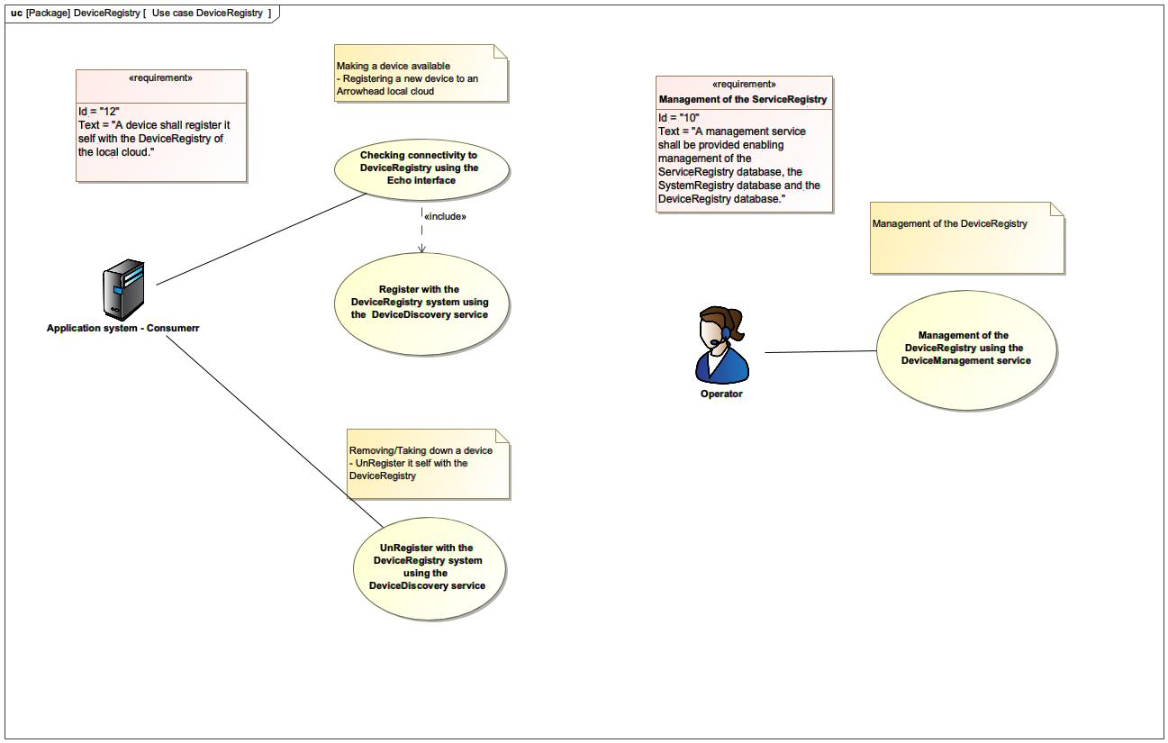

1. Use case DeviceRegistry

## Arrowhead architecture properties

NA

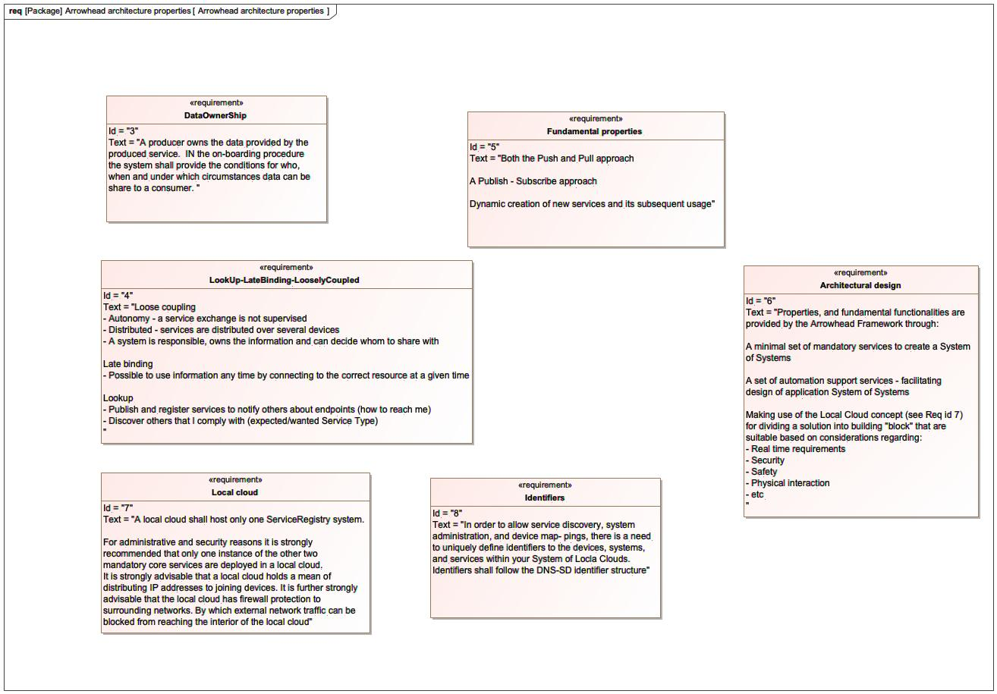

1. Arrowhead architecture properties

## Arrowhead doc structure

NA

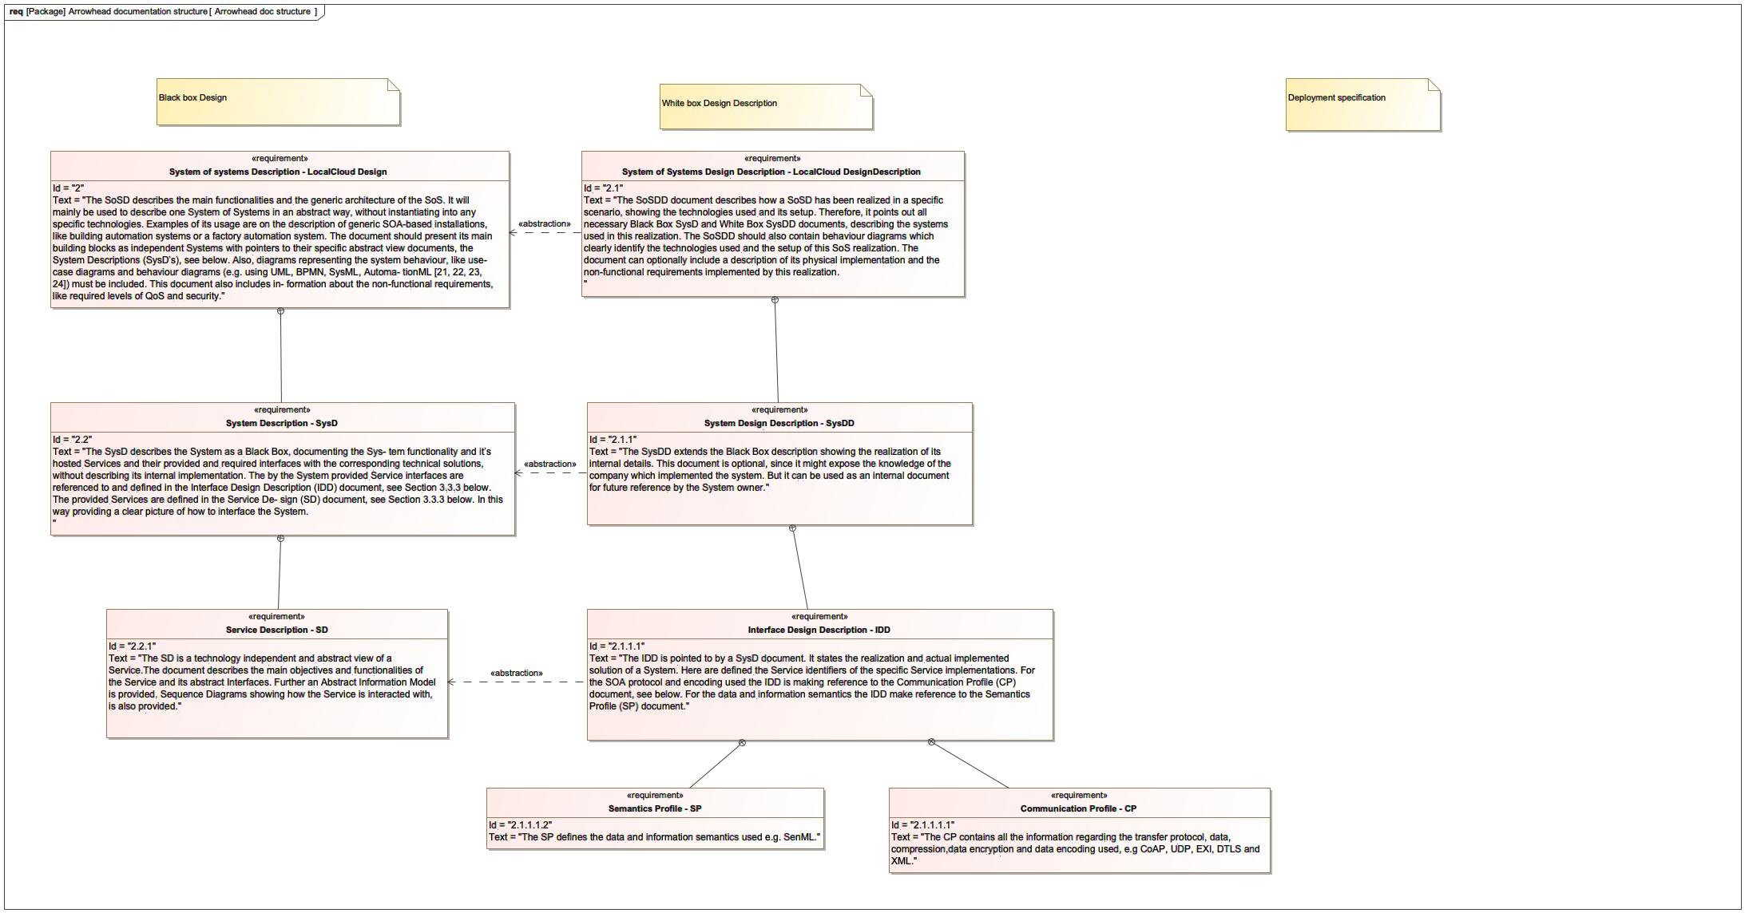

1. Arrowhead doc structure

## Authorisation

NA

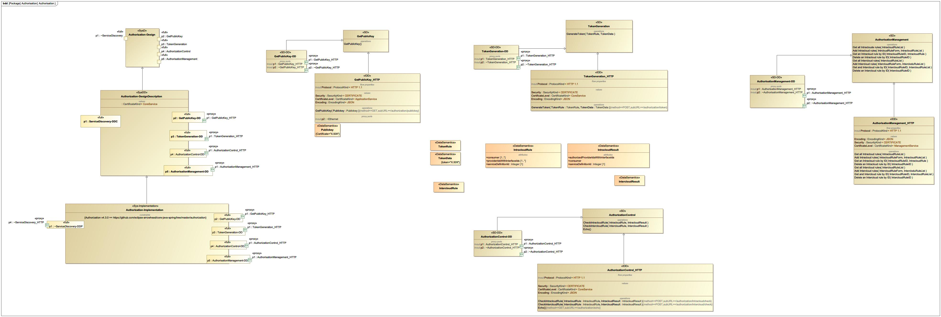

1. Authorisation

## CertificateAuthority

NA

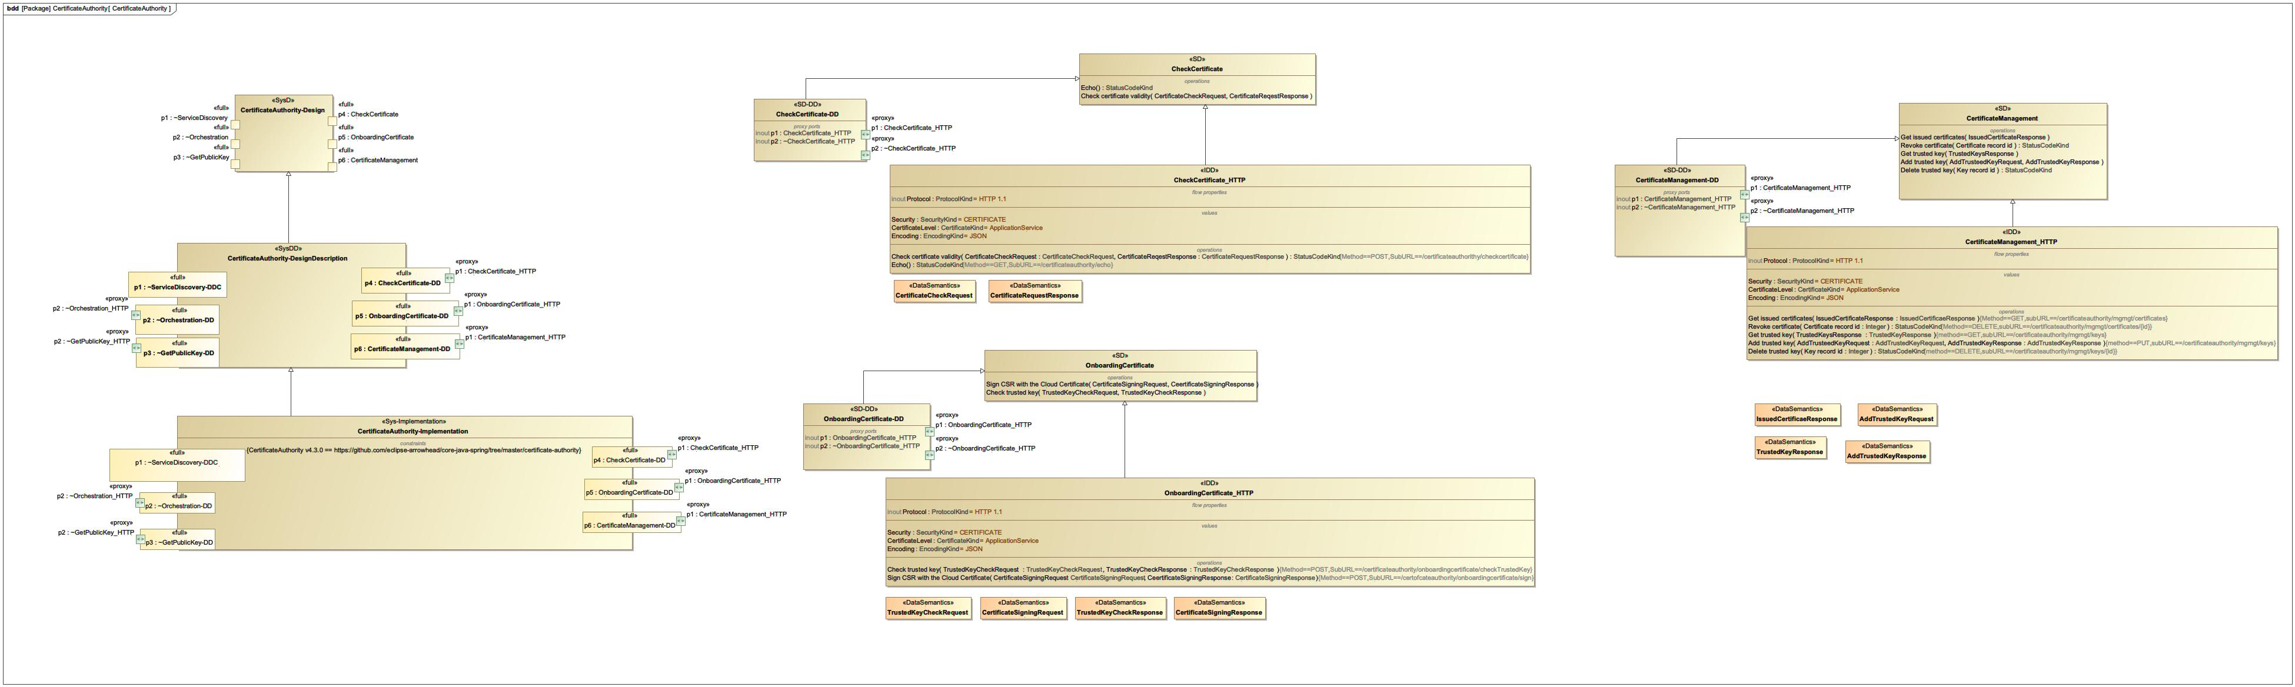

1. CertificateAuthority

## DataManager

NA

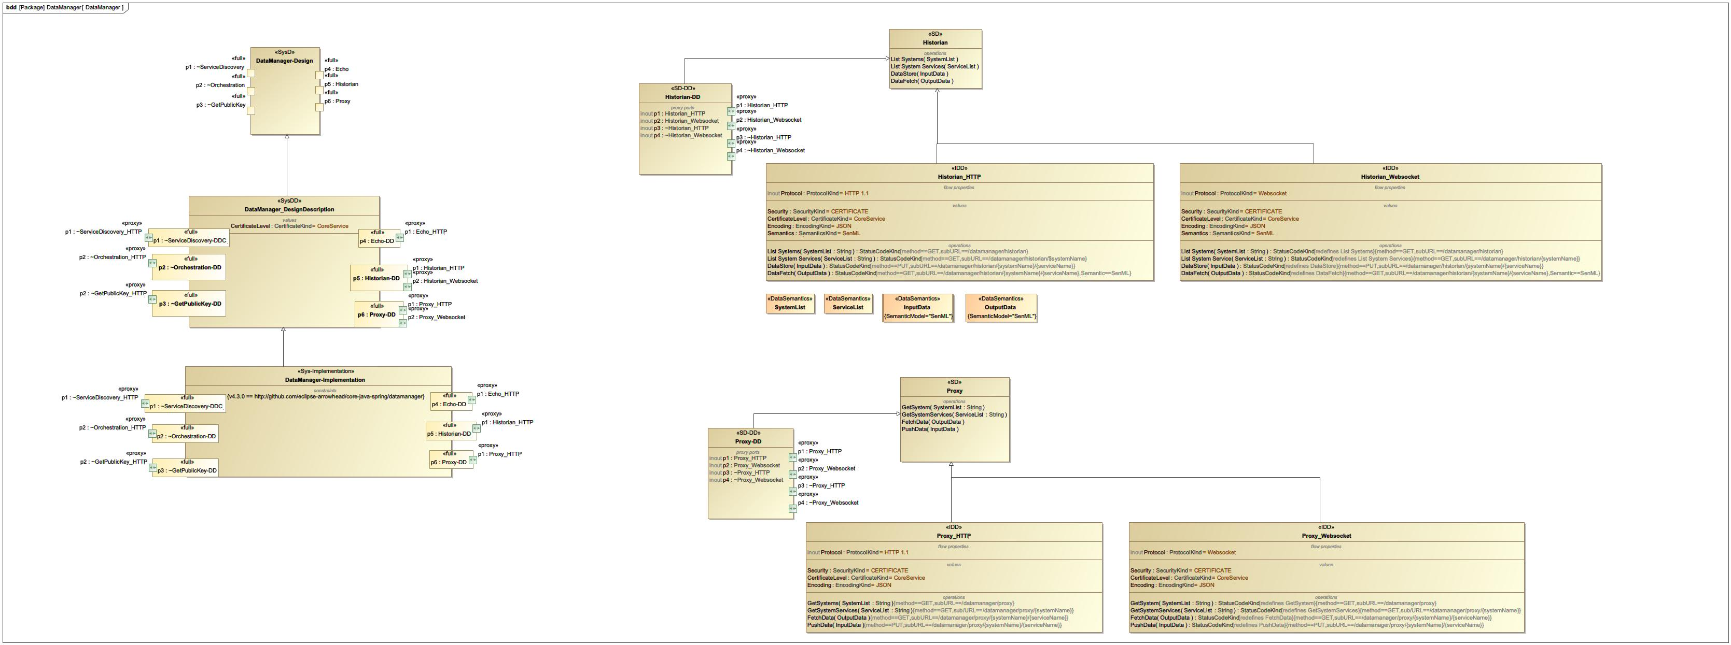

1. DataManager

## Device

NA

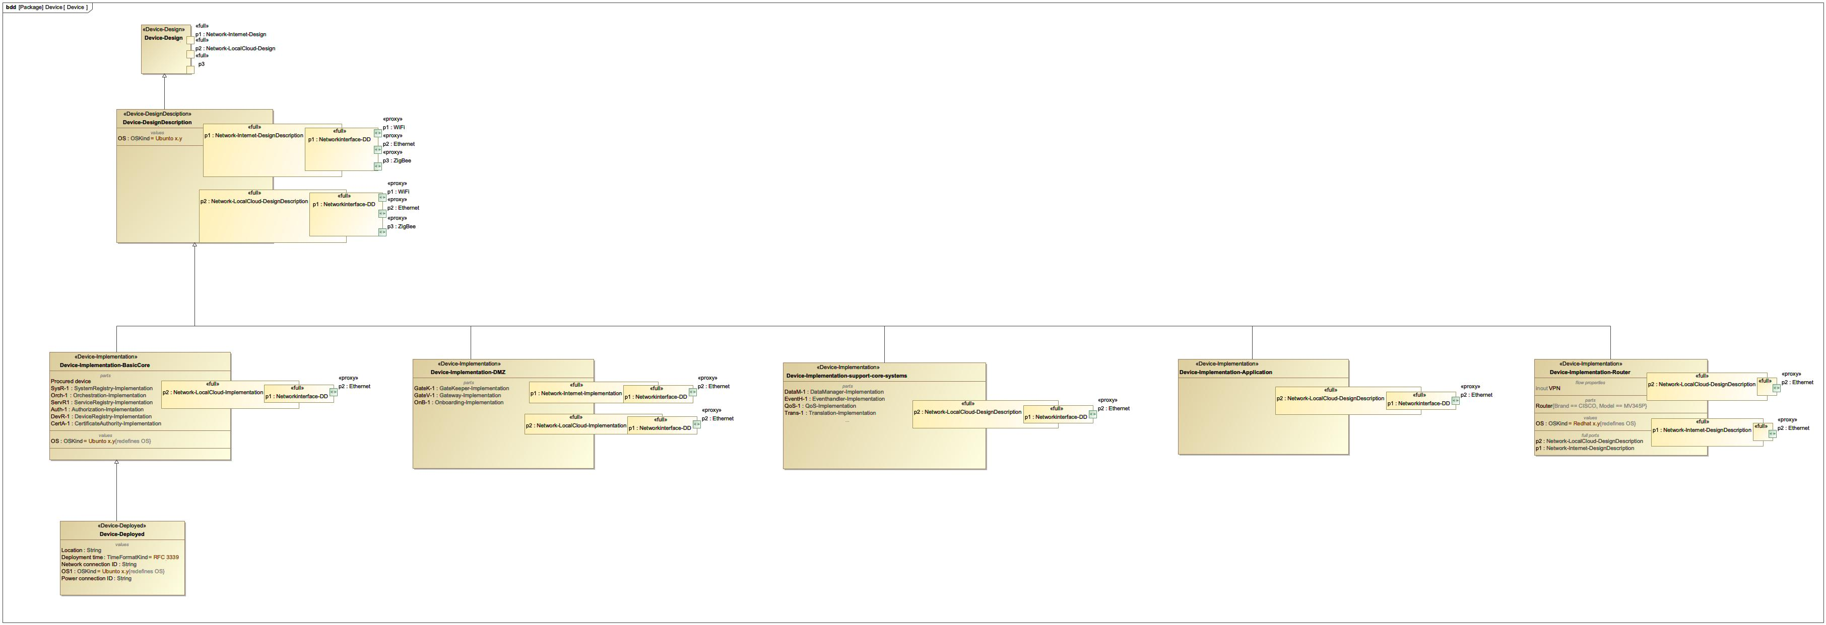

1. Device

## Device-Implementation-BasicCore

NA

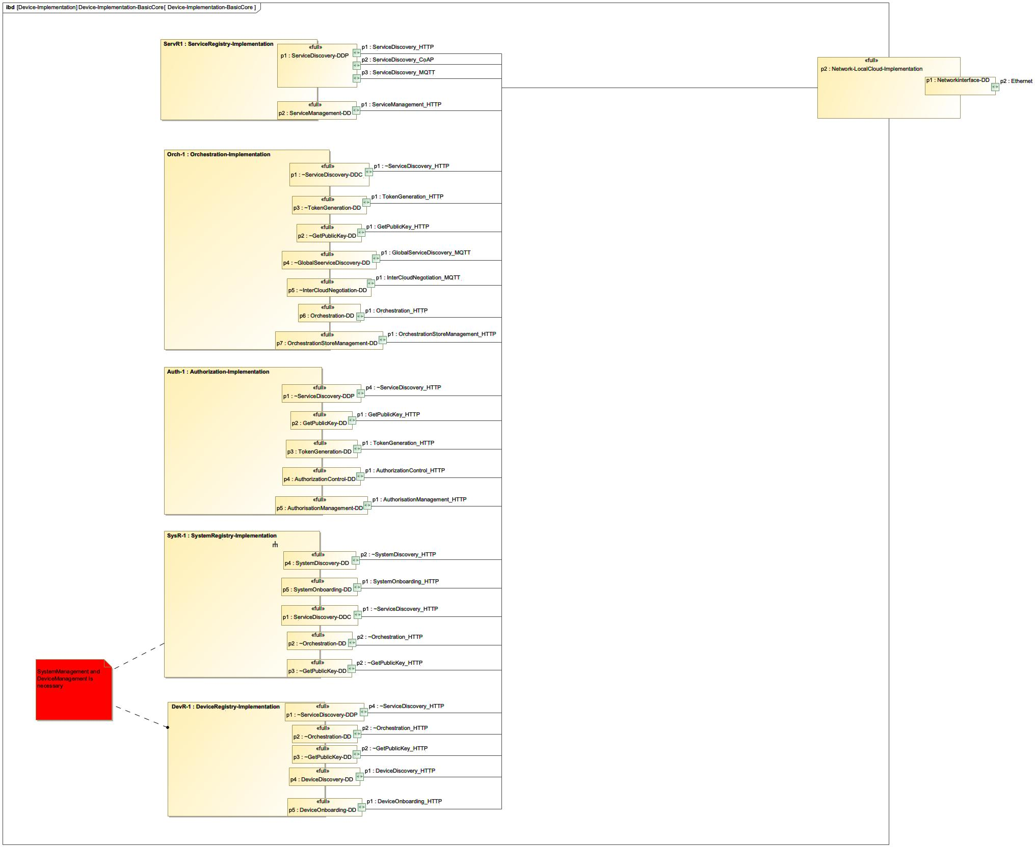

1. Device-Implementation-BasicCore

## Device-Implementation-DMZ

NA

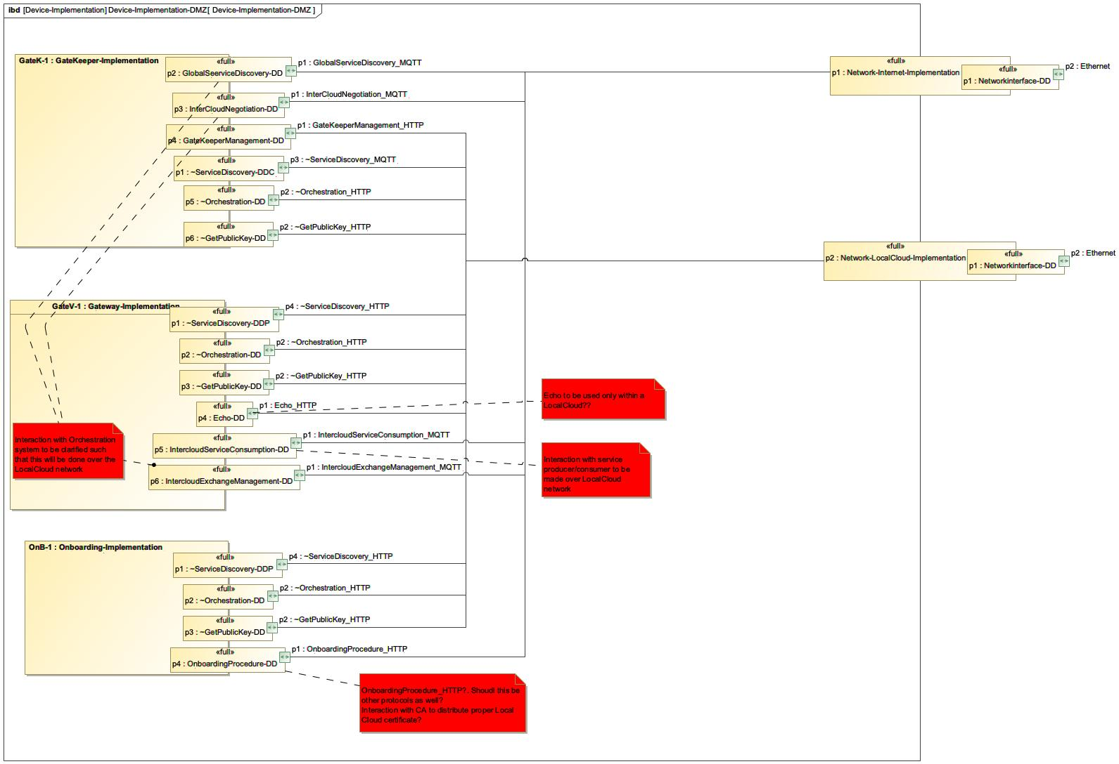

1. Device-Implementation-DMZ

## Device-Implementation-support-core-systems

NA

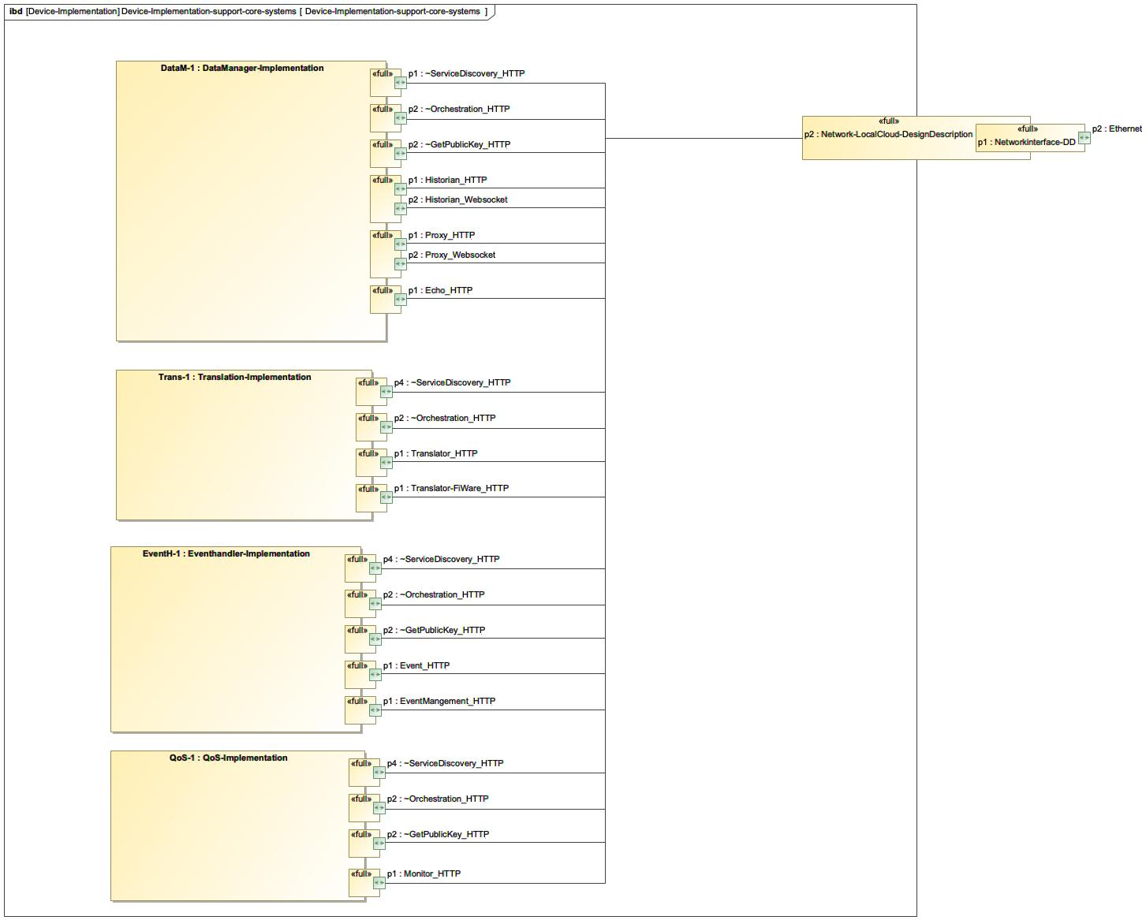

1. Device-Implementation-support-core-systems

## DeviceRegistry

NA

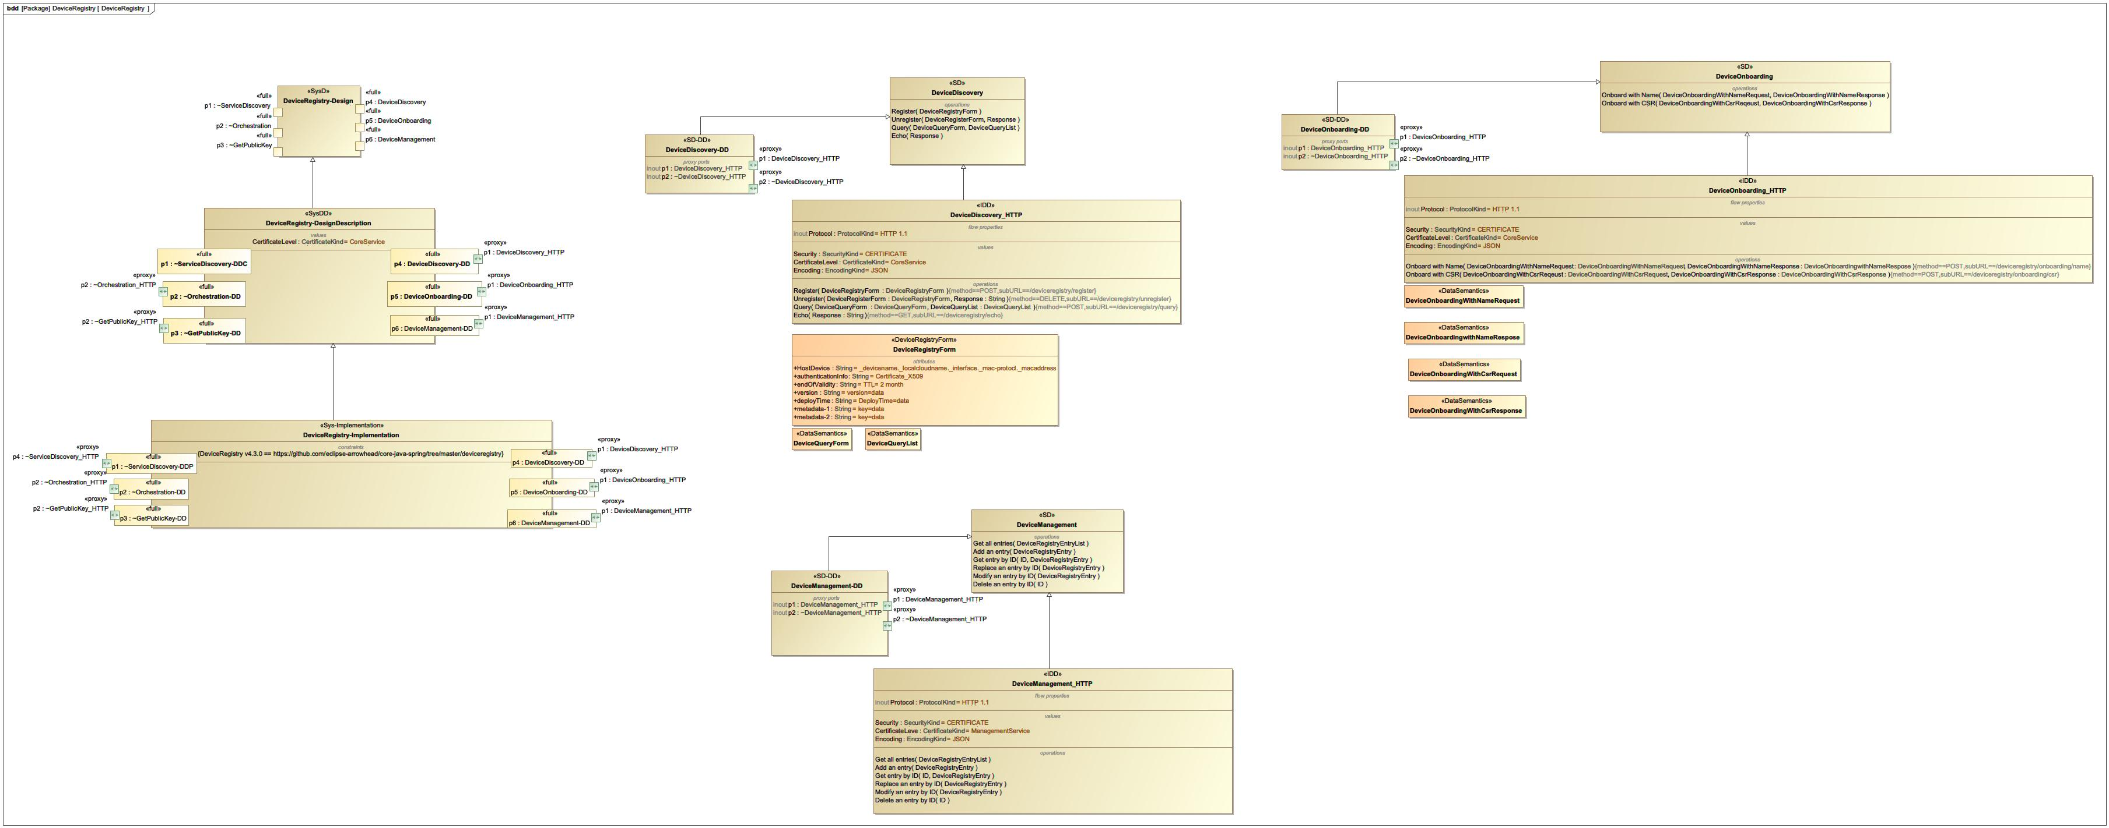

1. DeviceRegistry

## EventHandler

NA

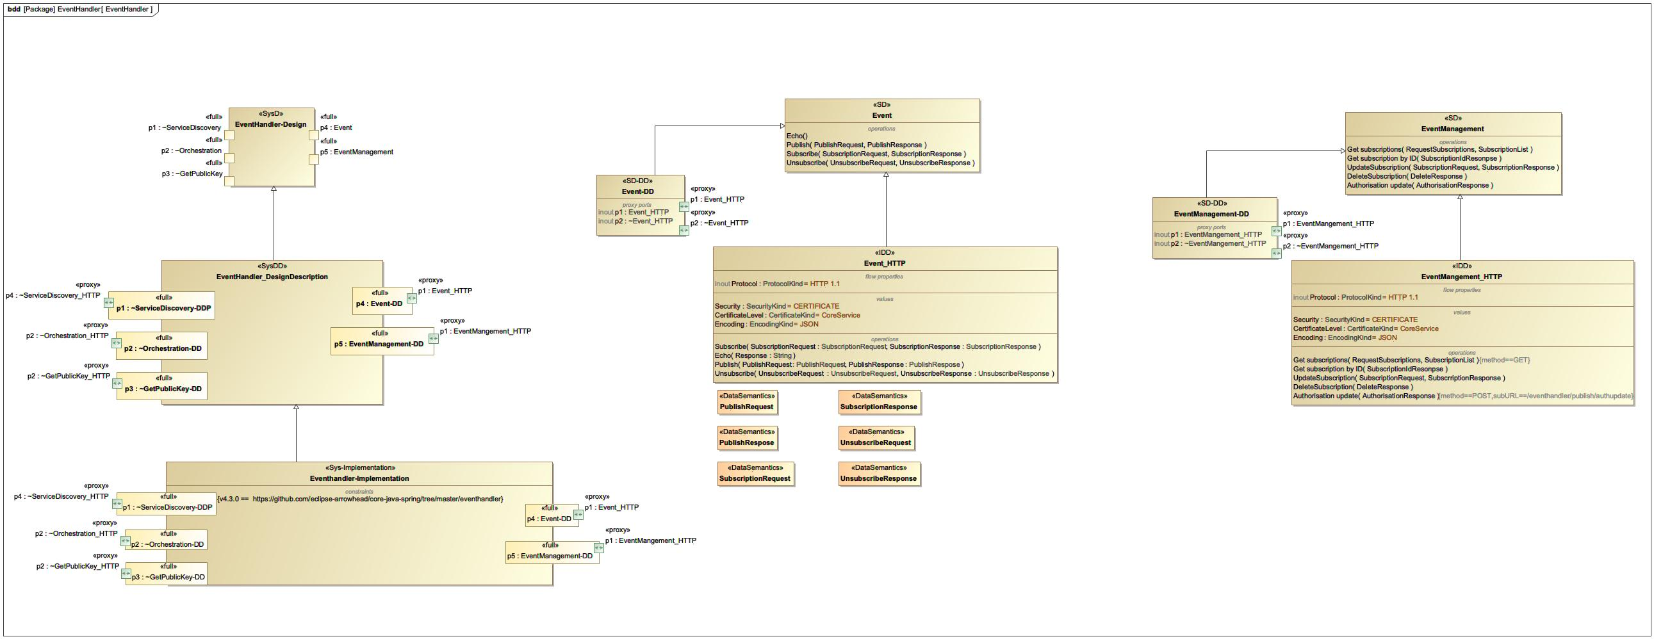

1. EventHandler

## GateKeeper

NA

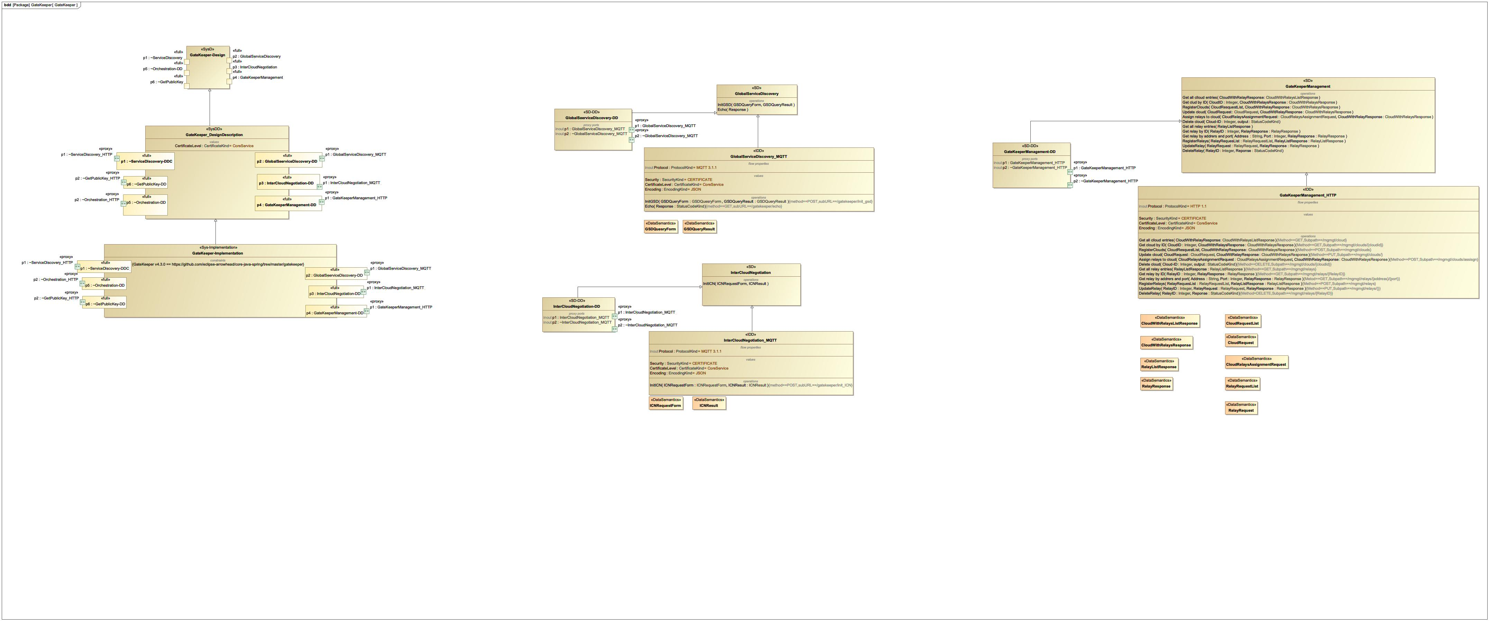

1. GateKeeper

## Gateway

NA

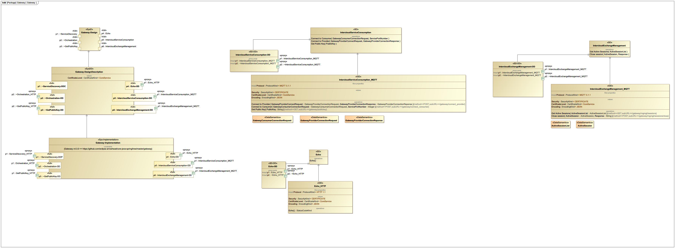

1. Gateway

## Generic_application_system

NA

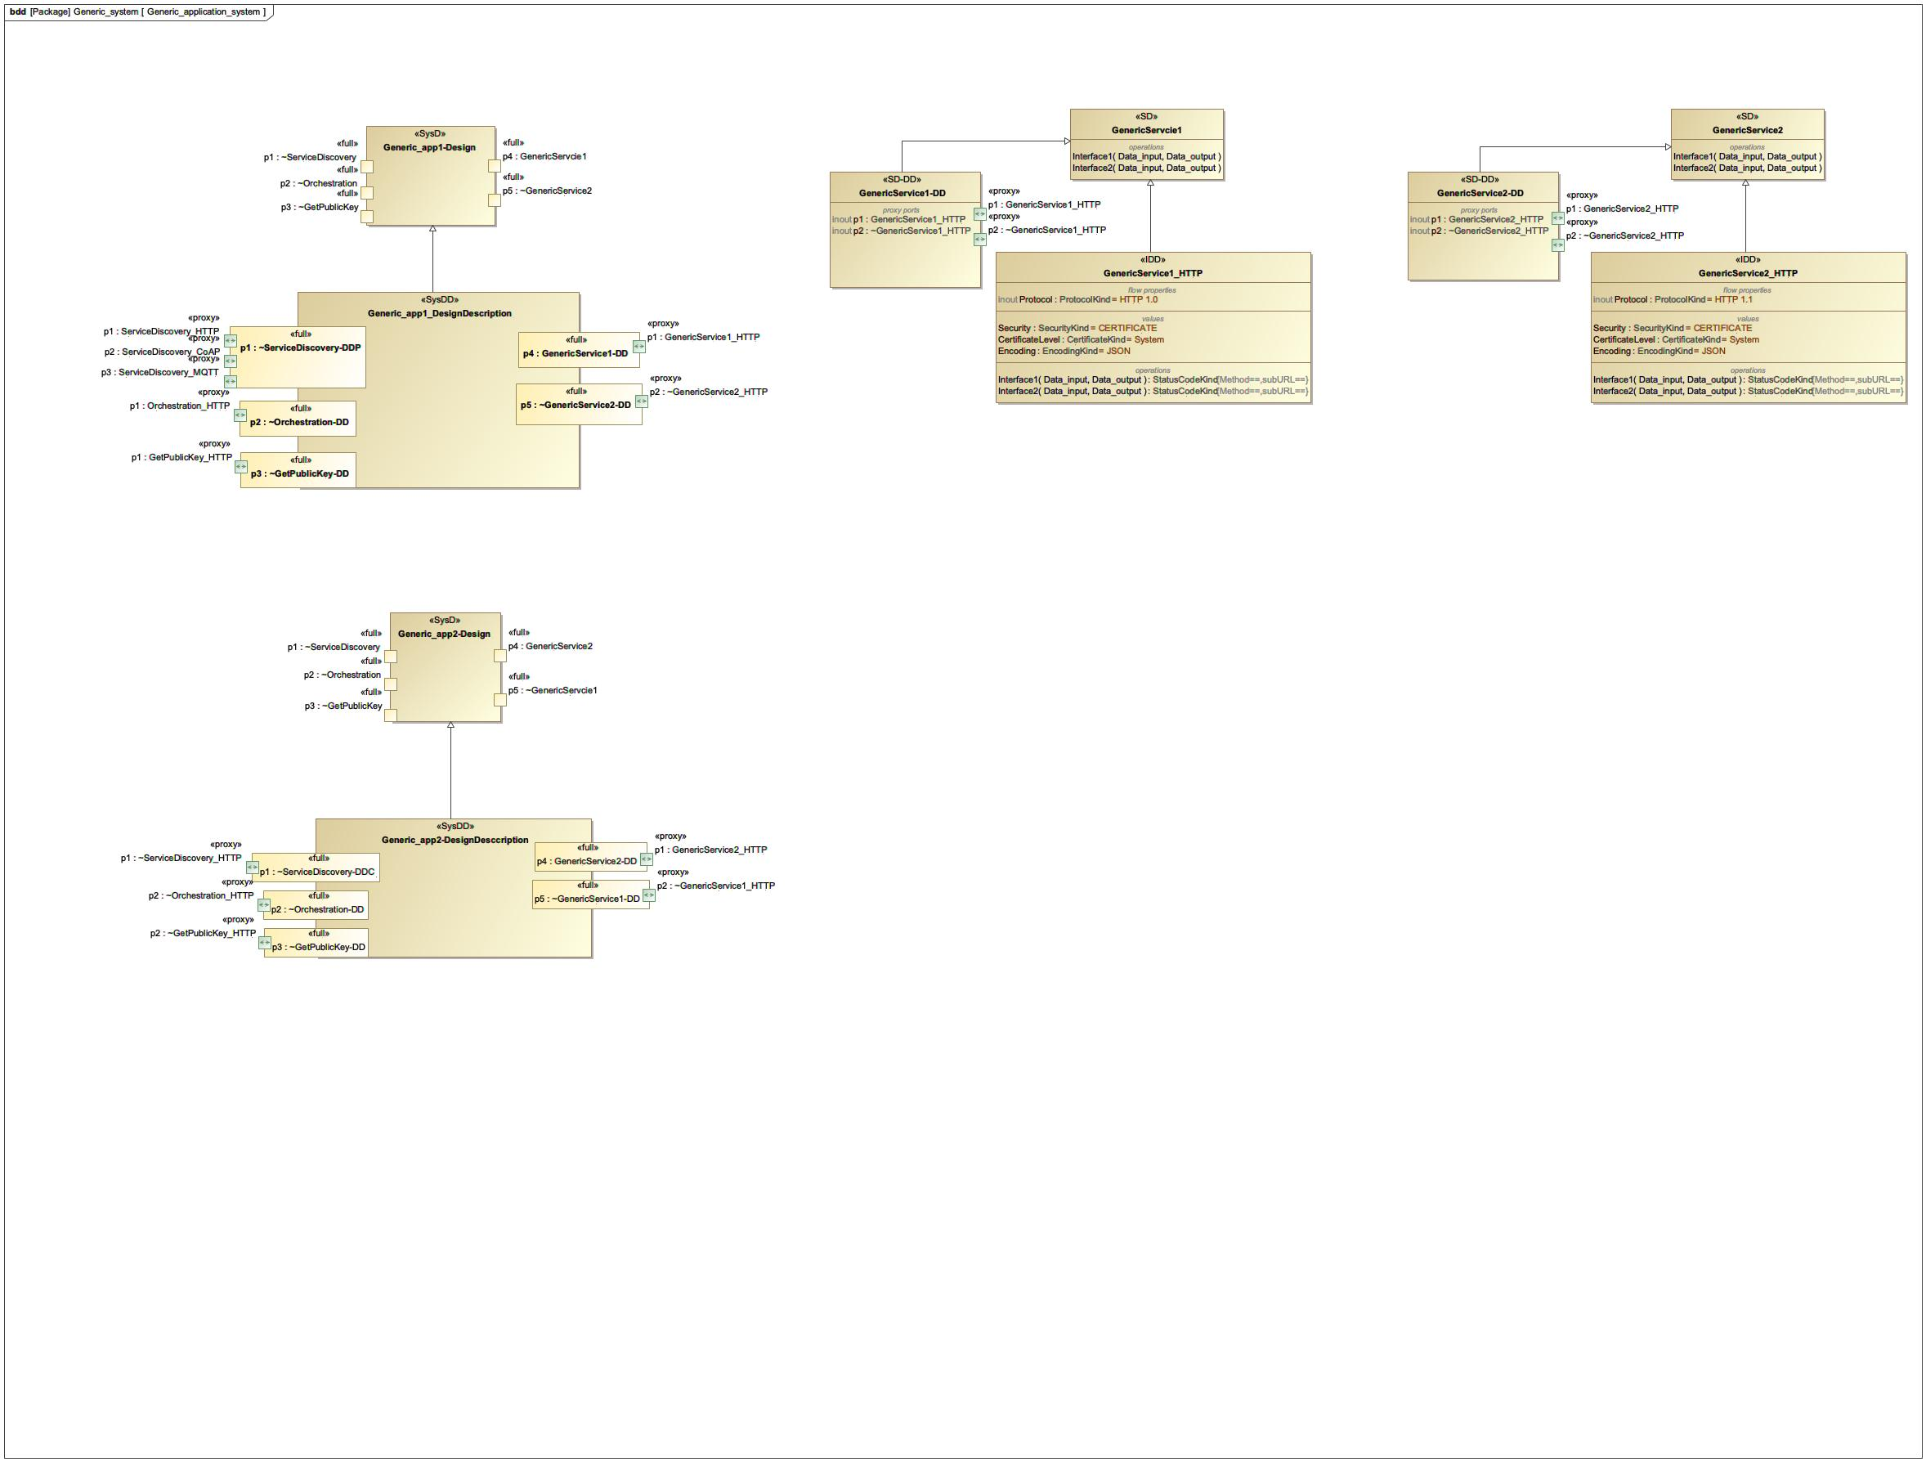

1. Generic_application_system

## Local Cloud

NA

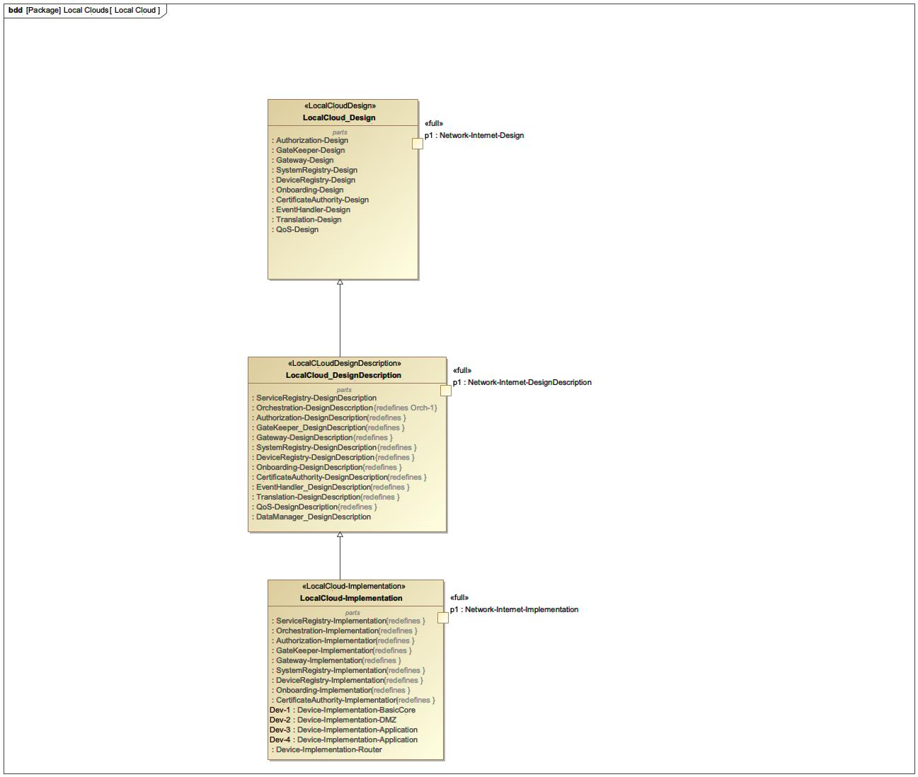

1. Local Cloud

## LocalCloud-Implementation

NA

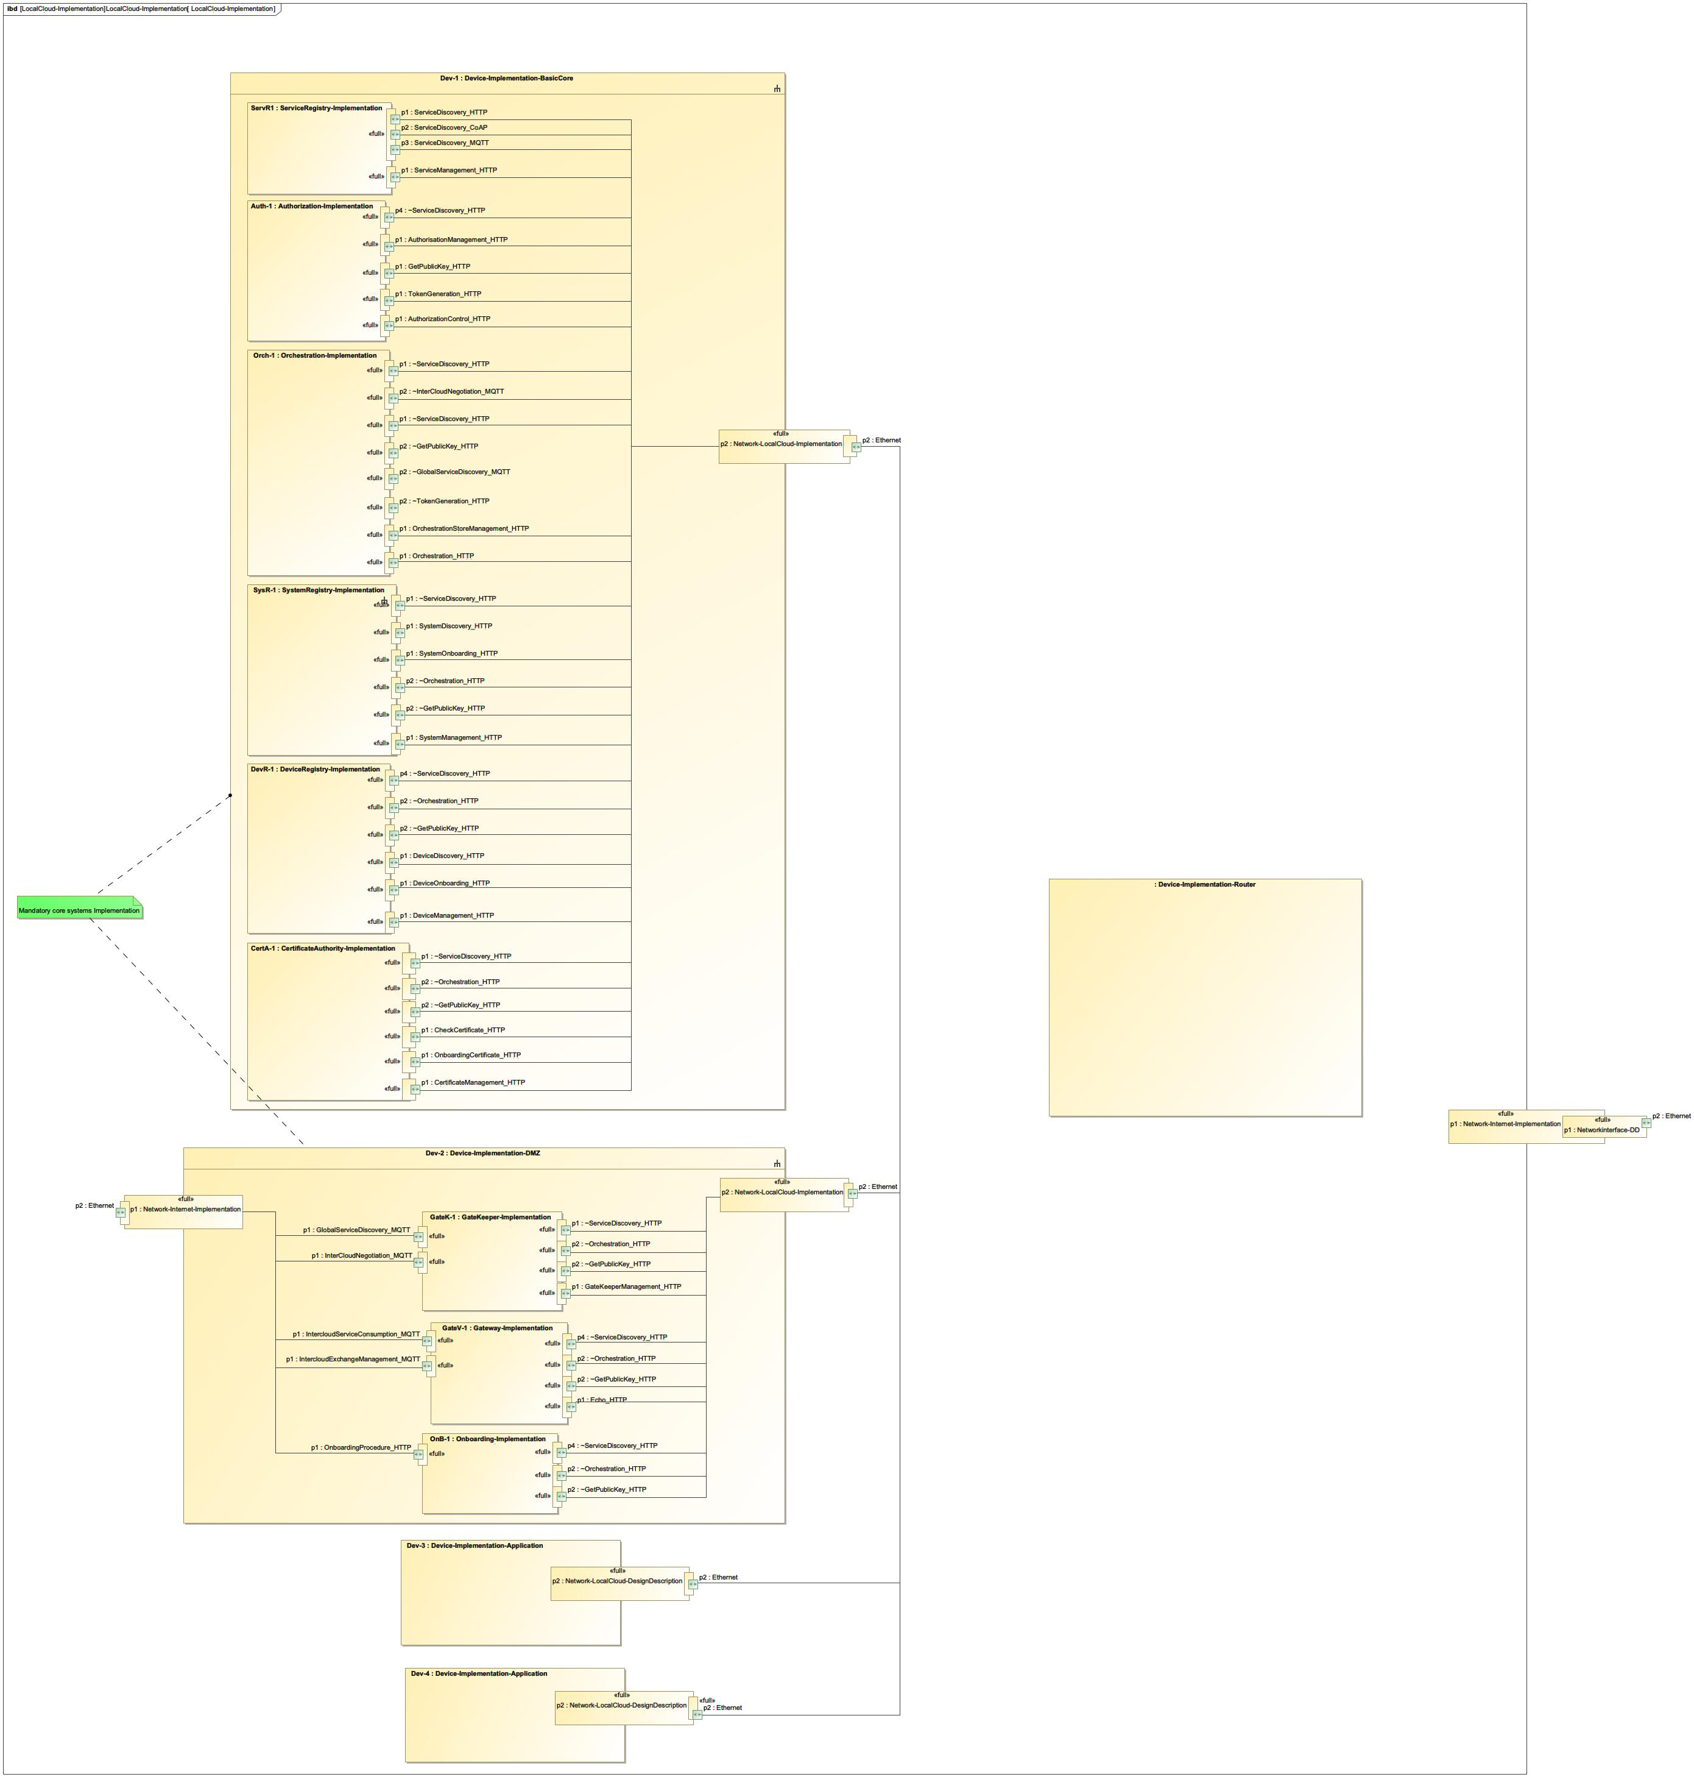

1. LocalCloud-Implementation

## LocalCloud_Design

NA

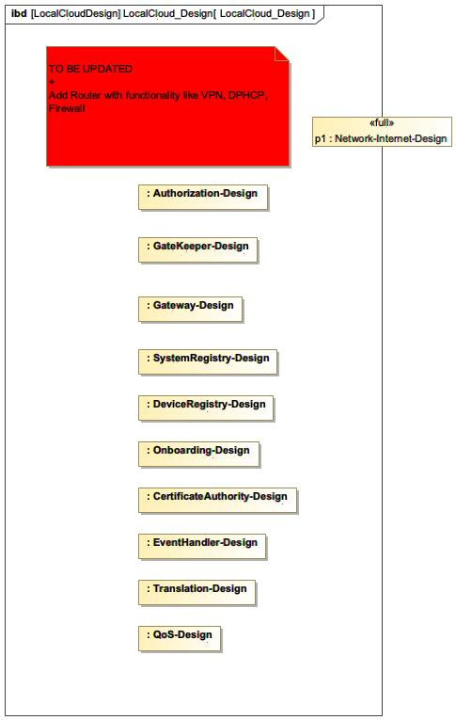

1. LocalCloud_Design

## LocalCloud_DesignDescription

NA

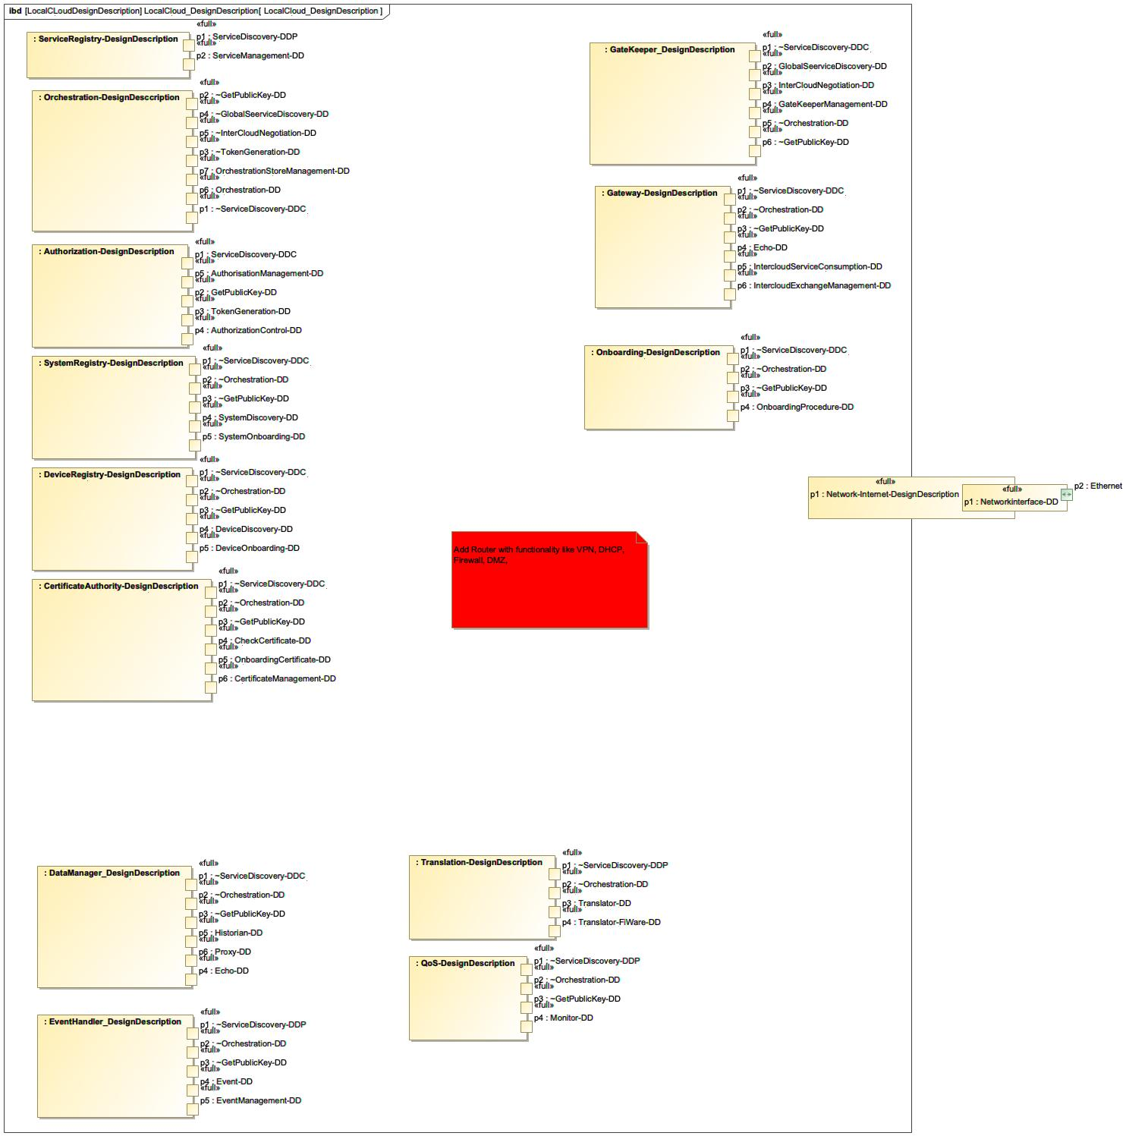

1. LocalCloud_DesignDescription

## MQTT_Brooker

NA

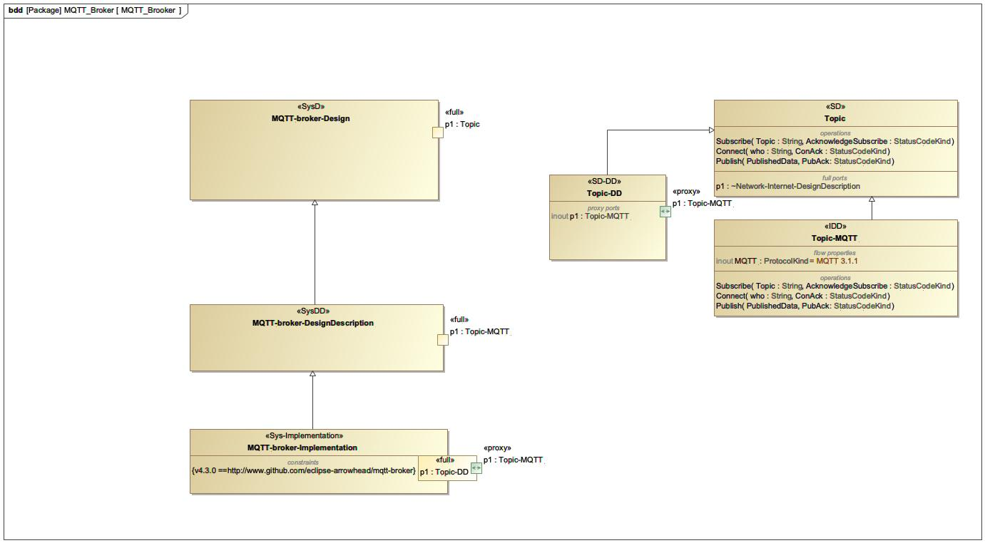

1. MQTT_Brooker

## Network

NA

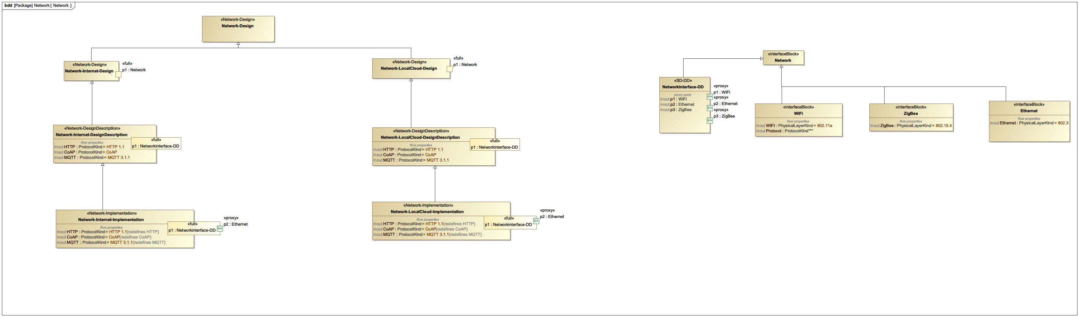

1. Network

## Onboarding

NA

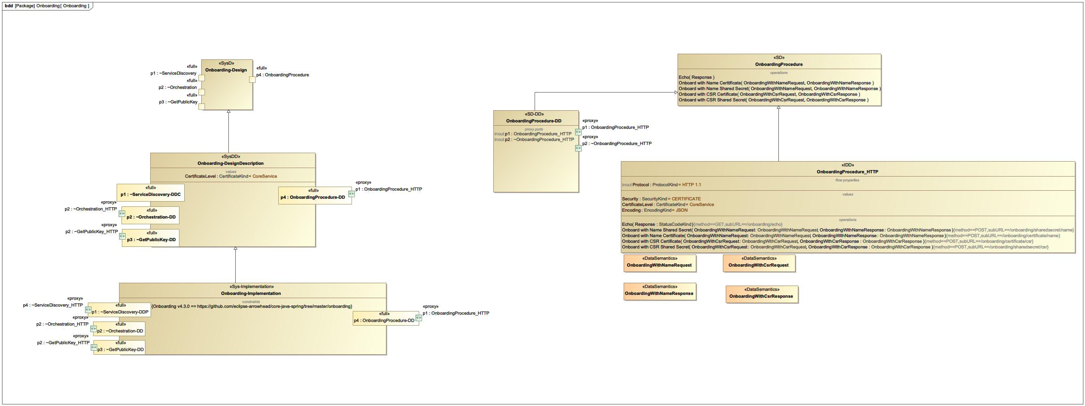

1. Onboarding

## Orchestration

NA

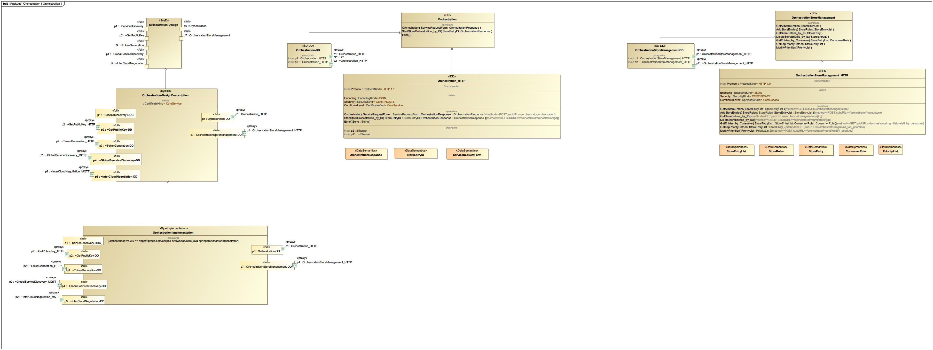

1. Orchestration

## Profile

NA

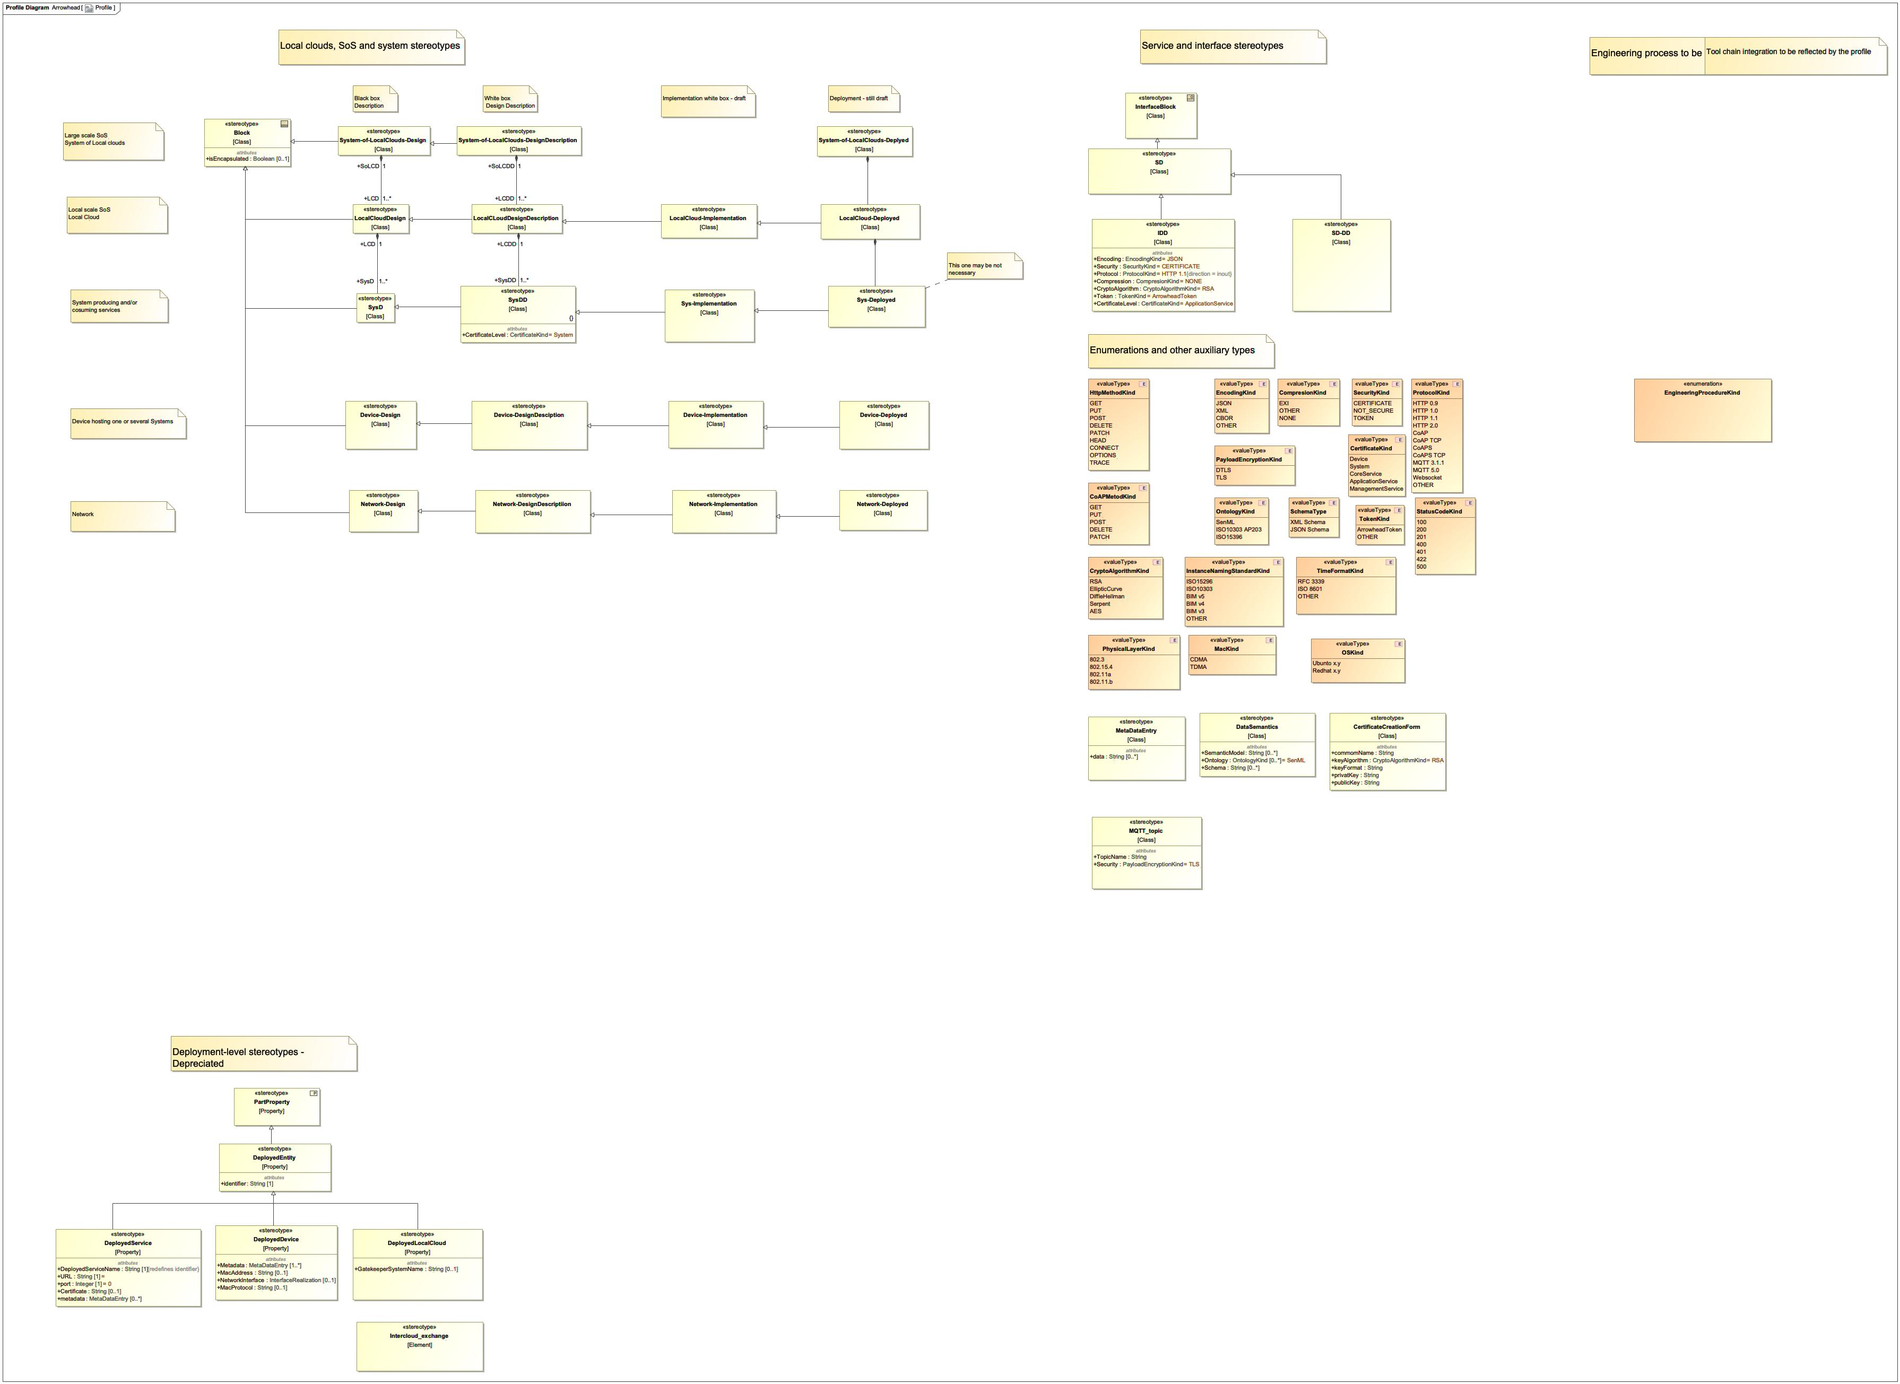

1. Profile

## QoS

NA

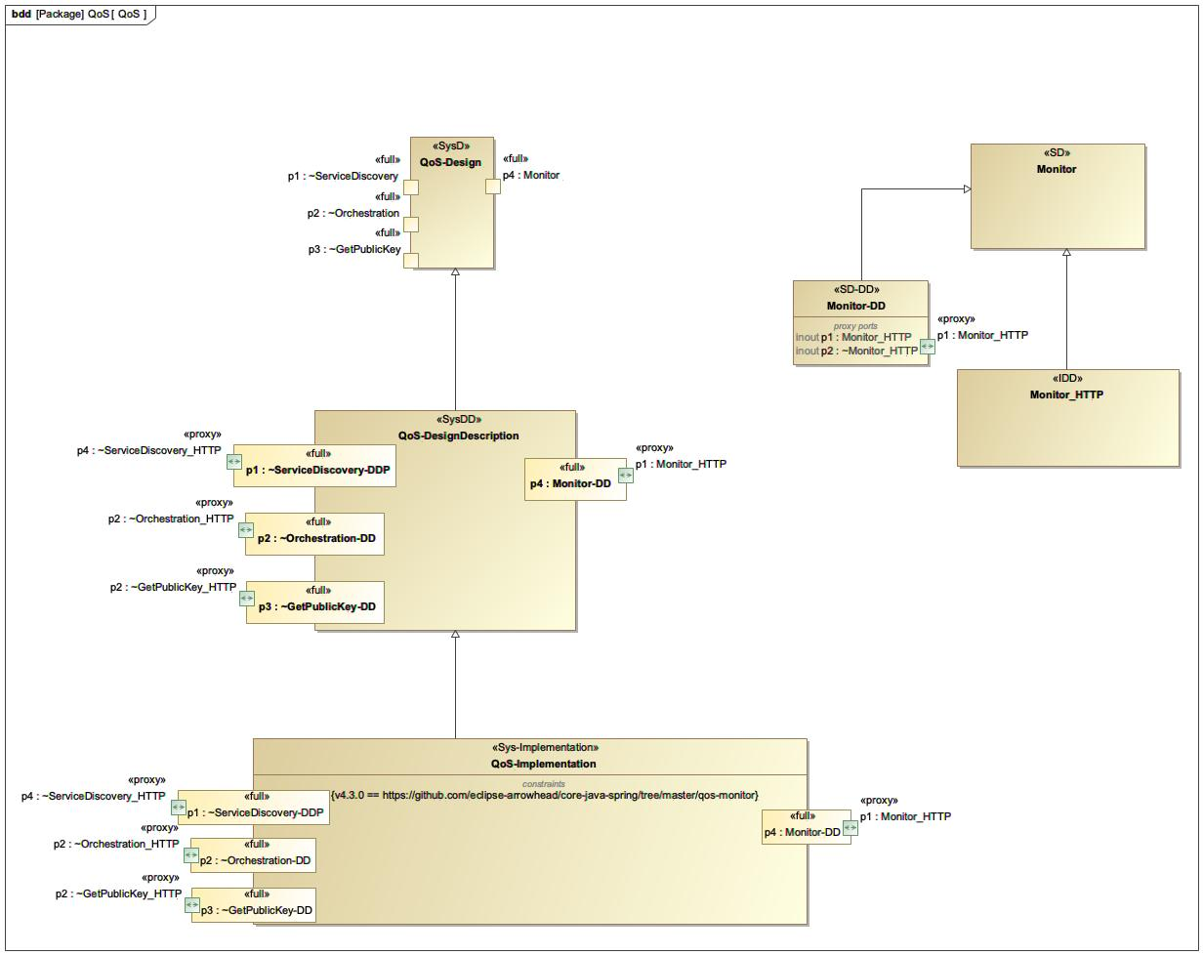

1. QoS

## ServiceRegistry

NA

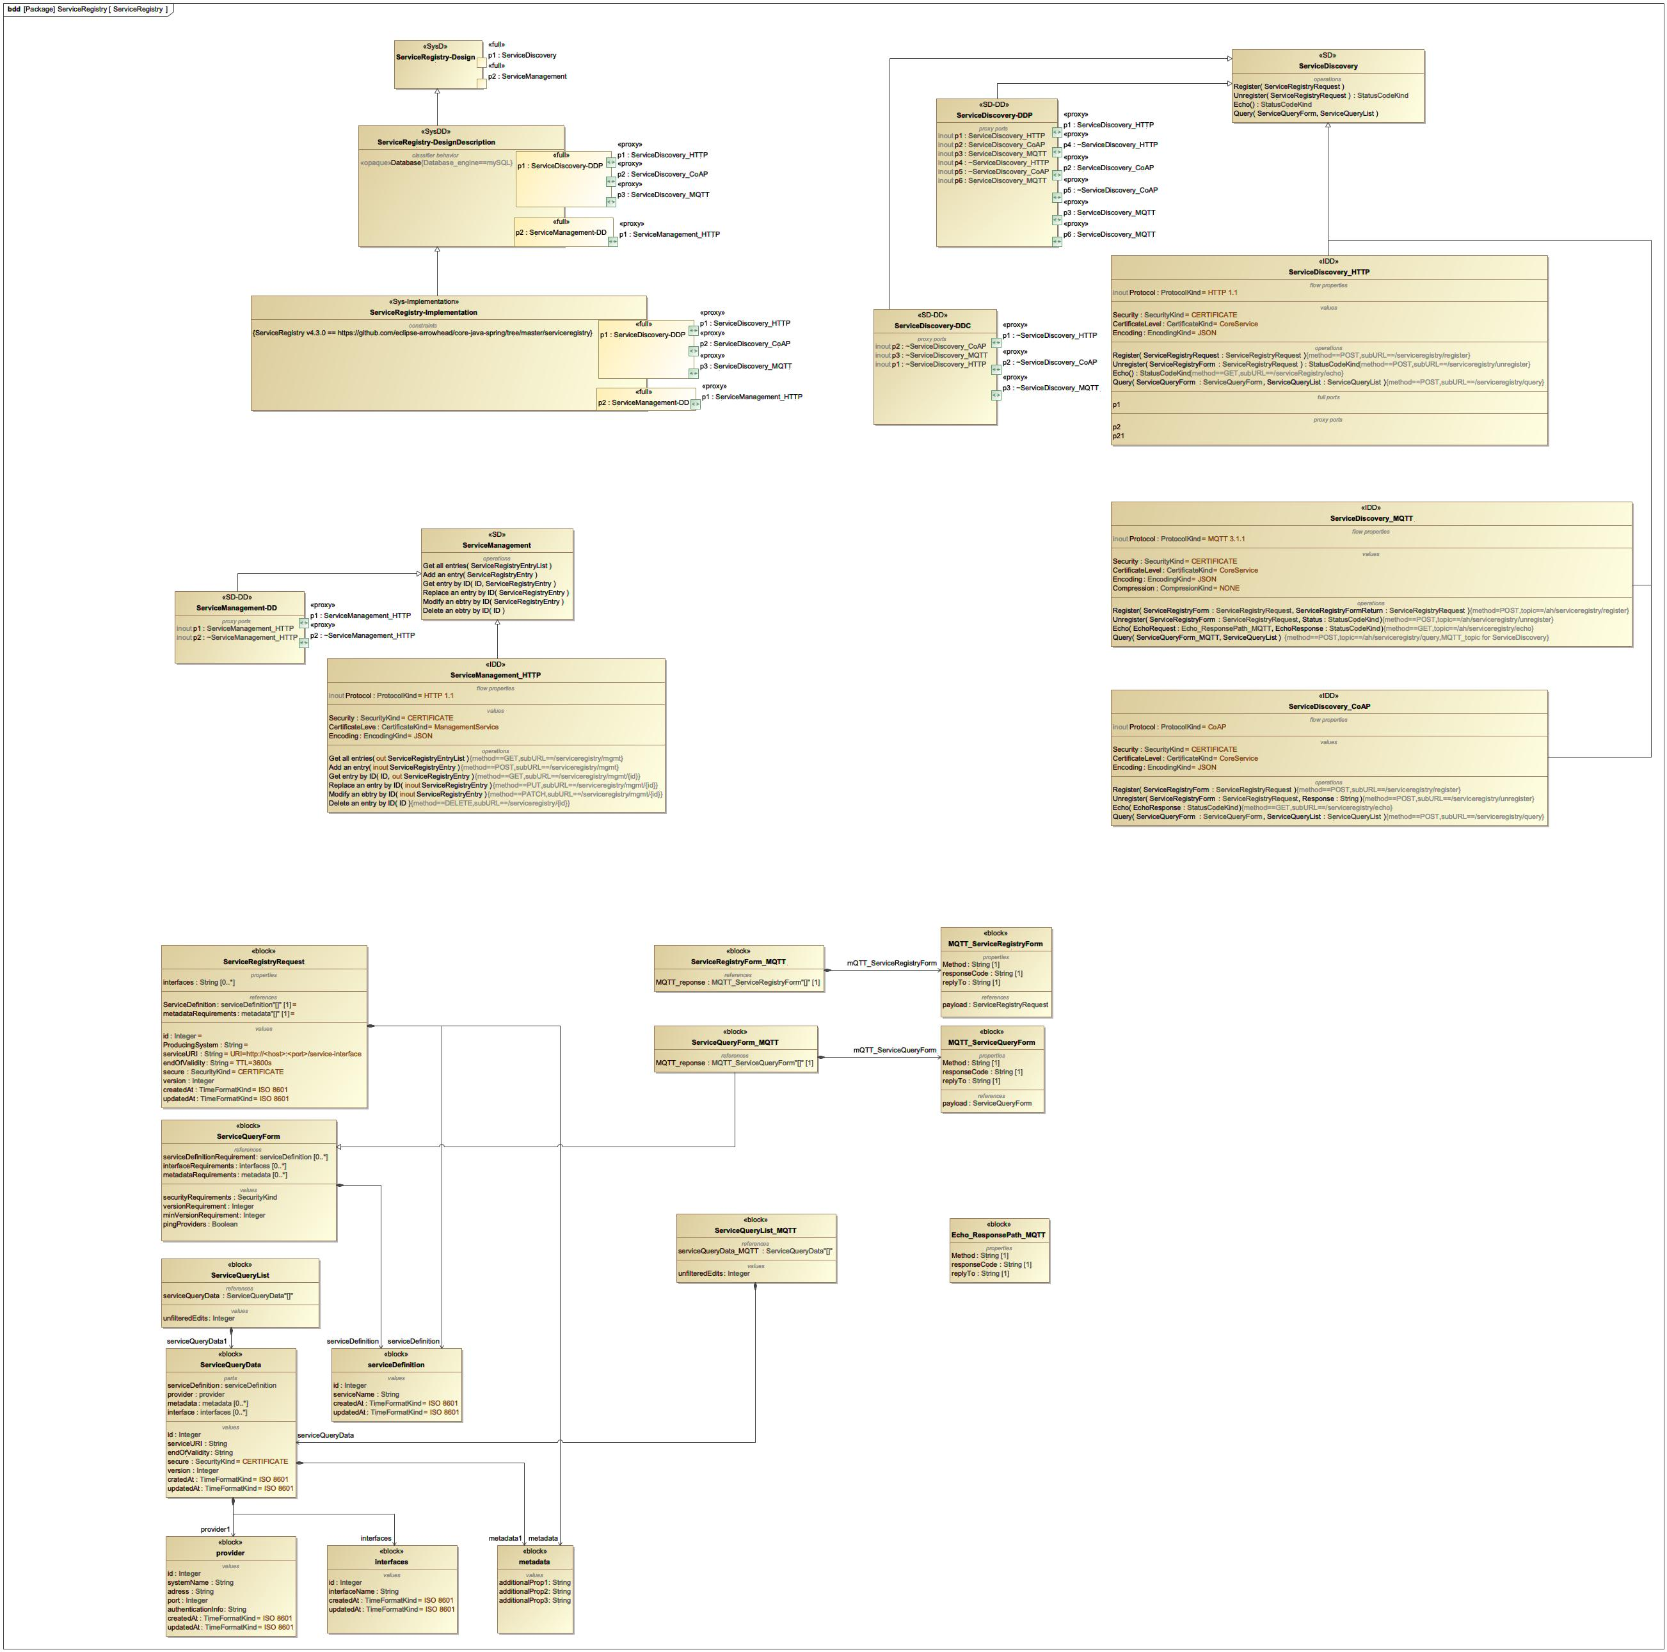

1. ServiceRegistry

## SoLC-Implementation

NA

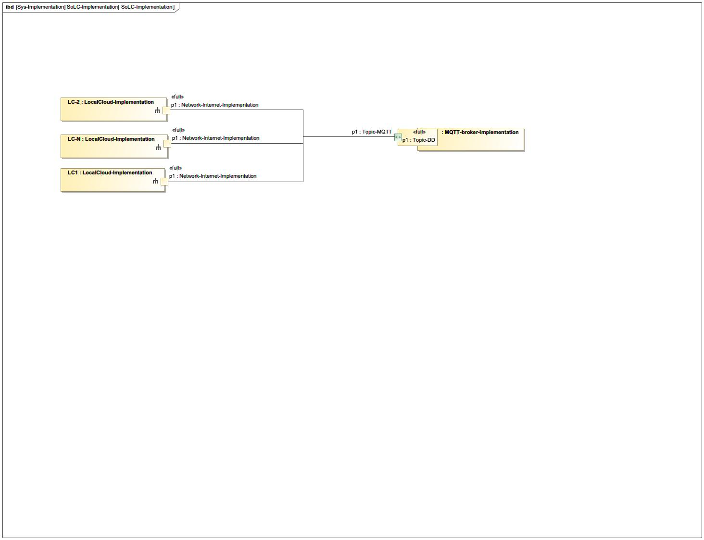

1. SoLC-Implementation

## SoLC_Design

NA

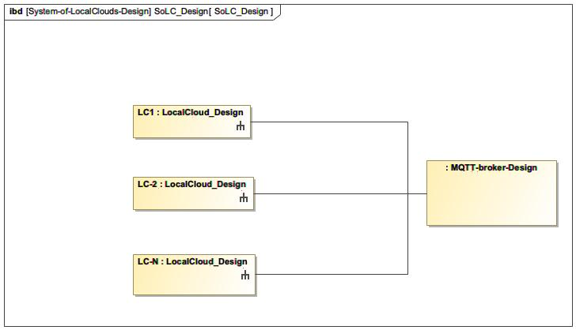

1. SoLC_Design

## SoLC_DesignDescription

NA

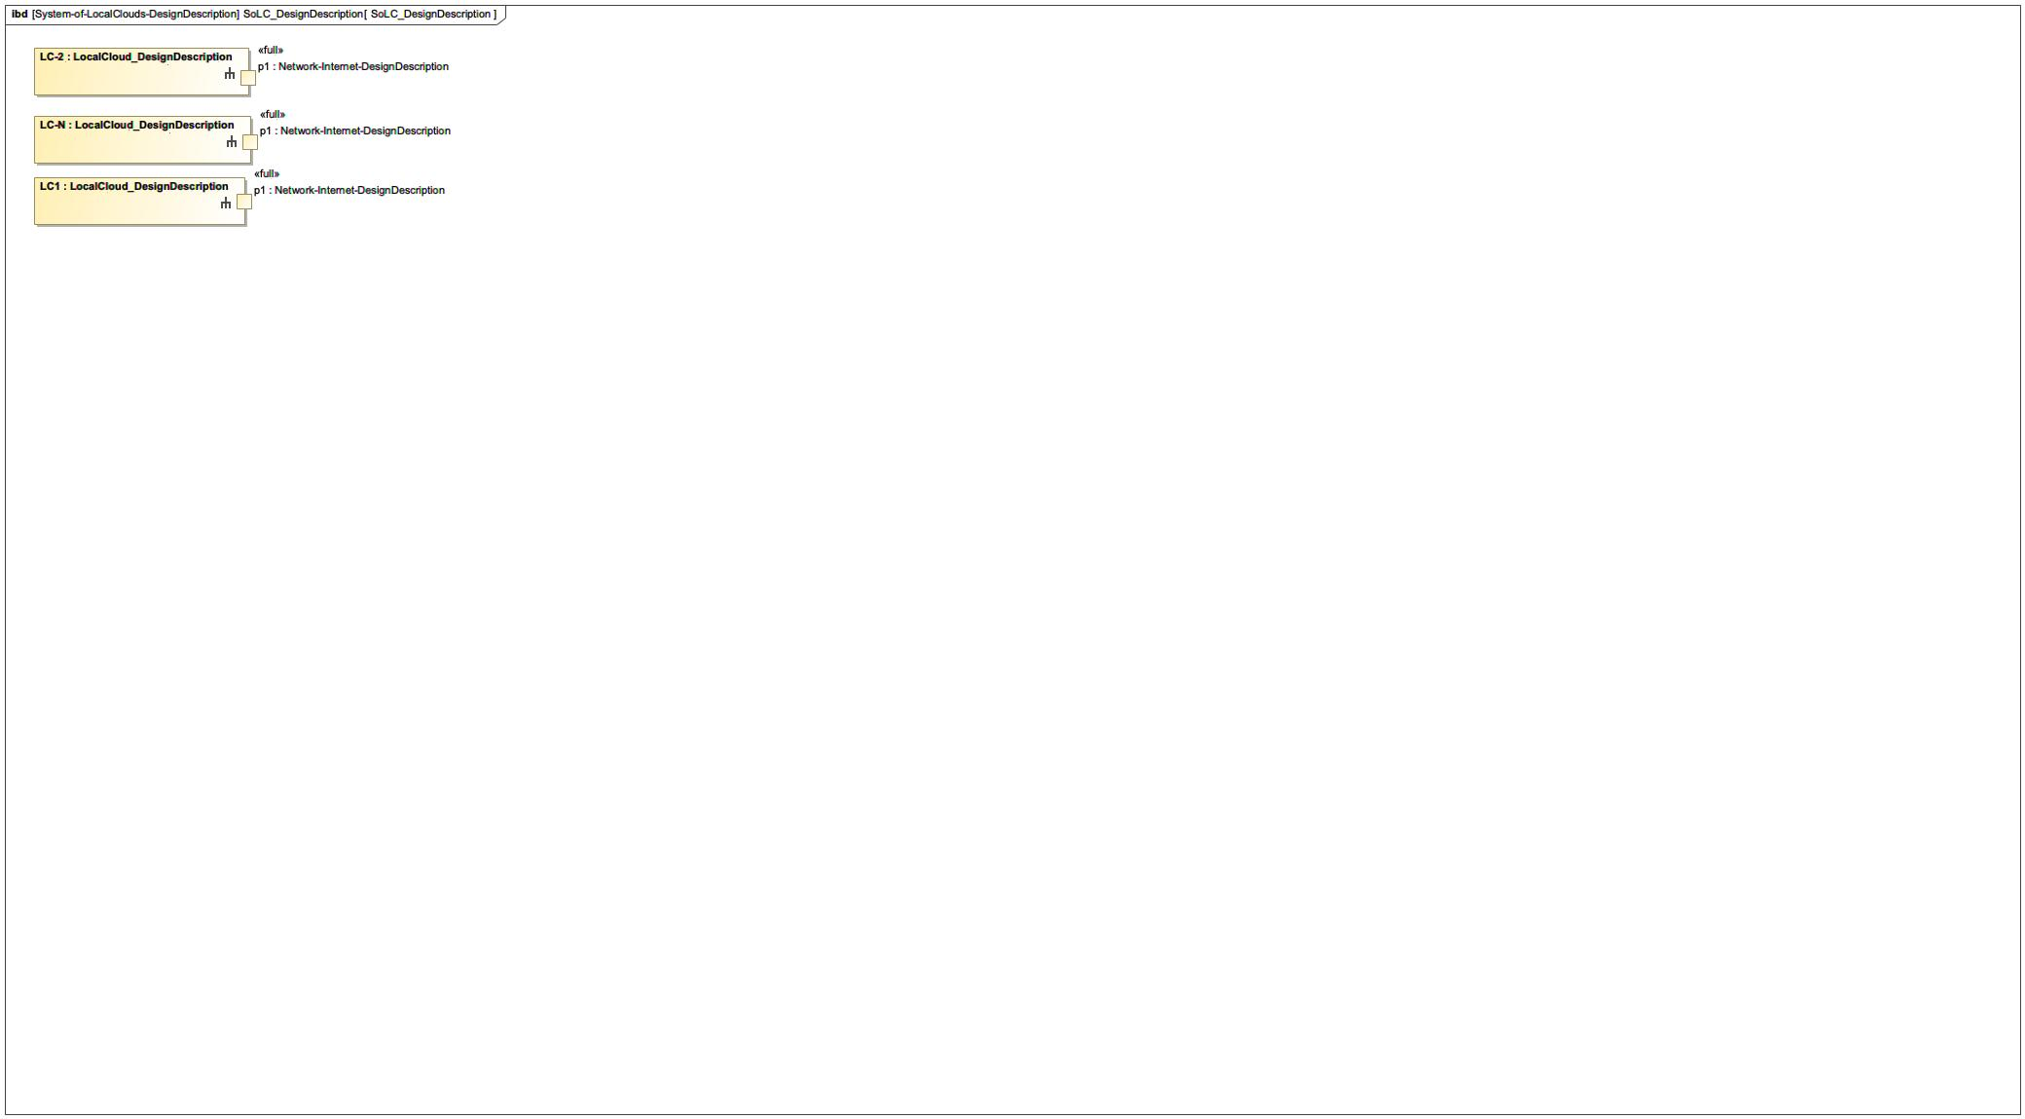

1. SoLC_DesignDescription

## SystemRegistry

NA

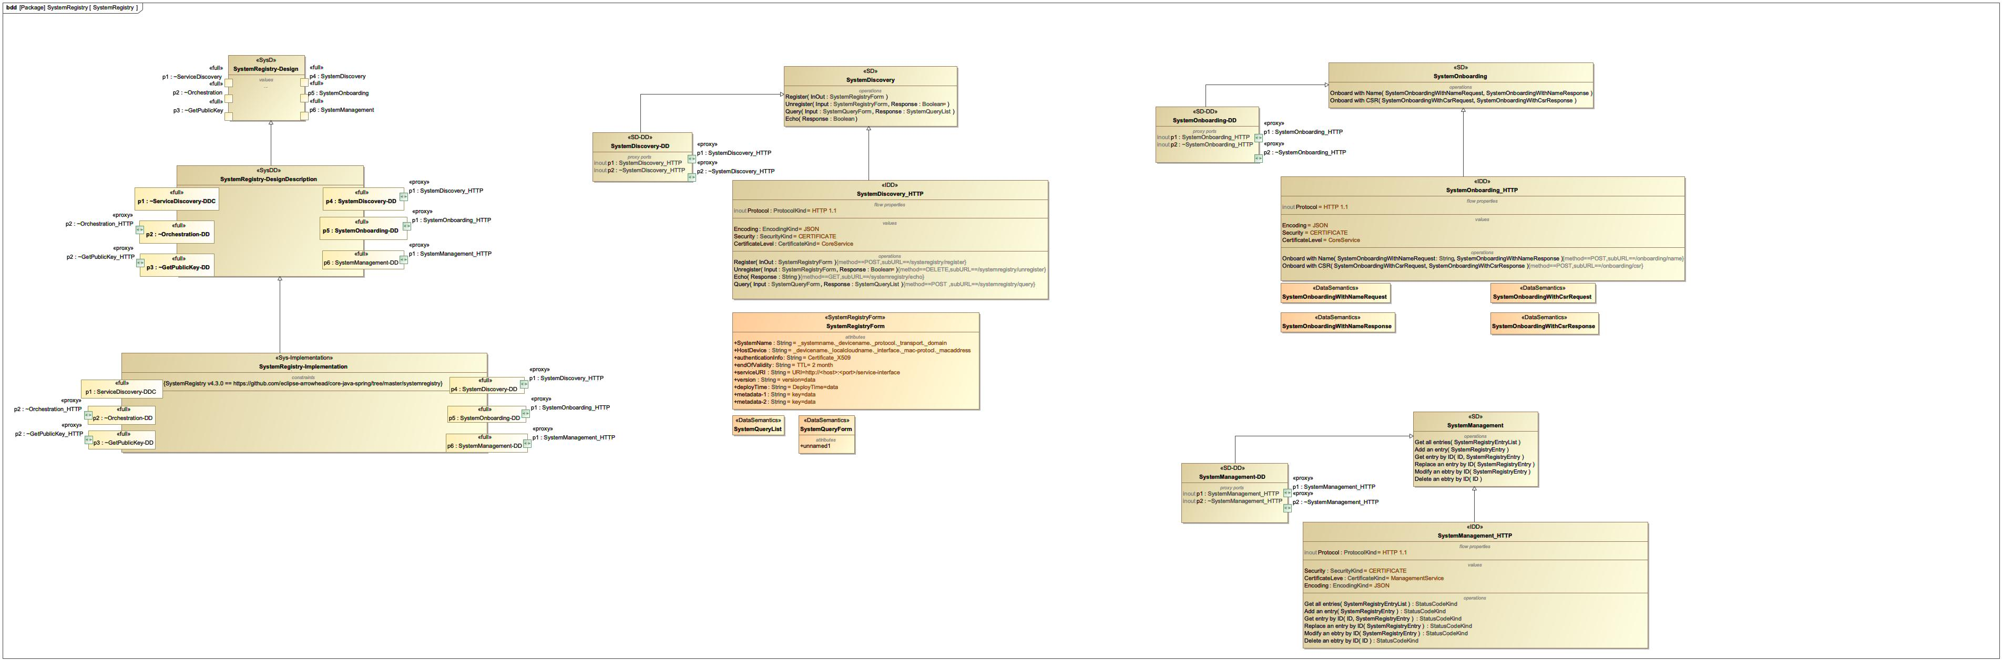

1. SystemRegistry

## SystemRegistry-Implementation

NA

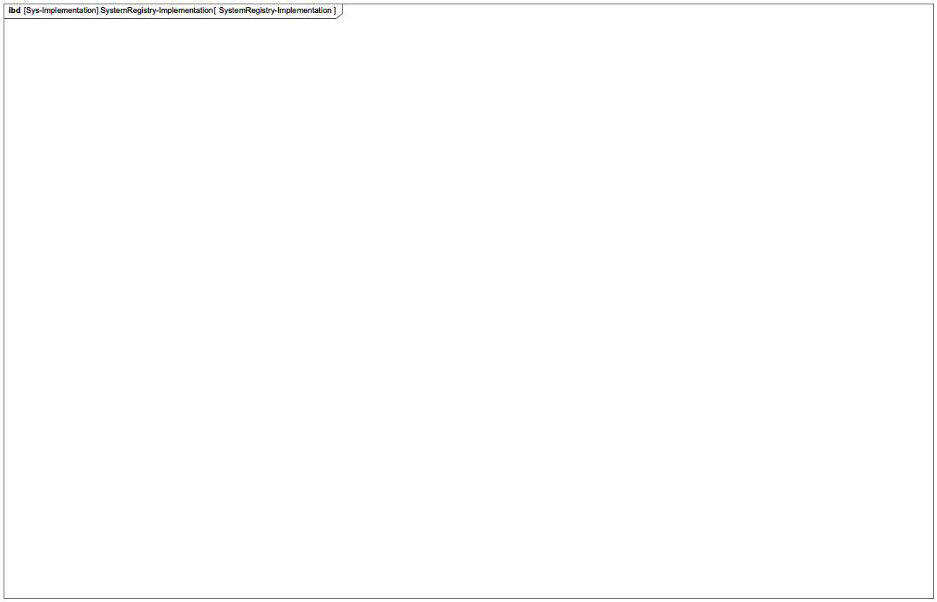

1. SystemRegistry-Implementation

## SystemRegistry-Implementation

NA

219596438.jpg

1. SystemRegistry-Implementation

## System_of_LocalClouds

NA

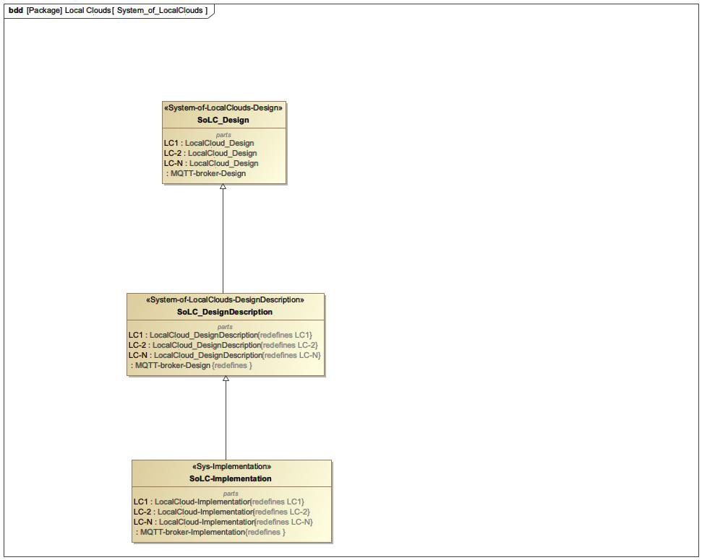

1. System_of_LocalClouds

## Translation

NA

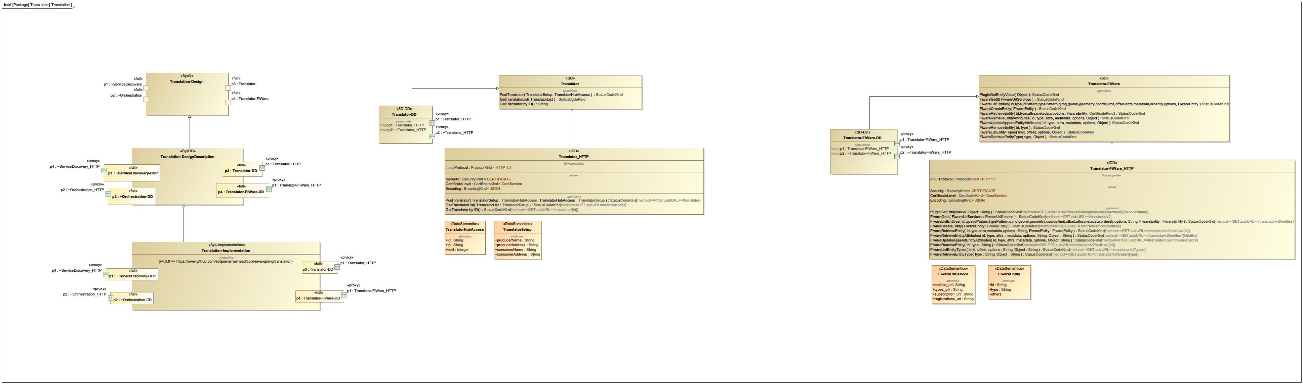

1. Translation

## Use case ServiceRegistry

NA

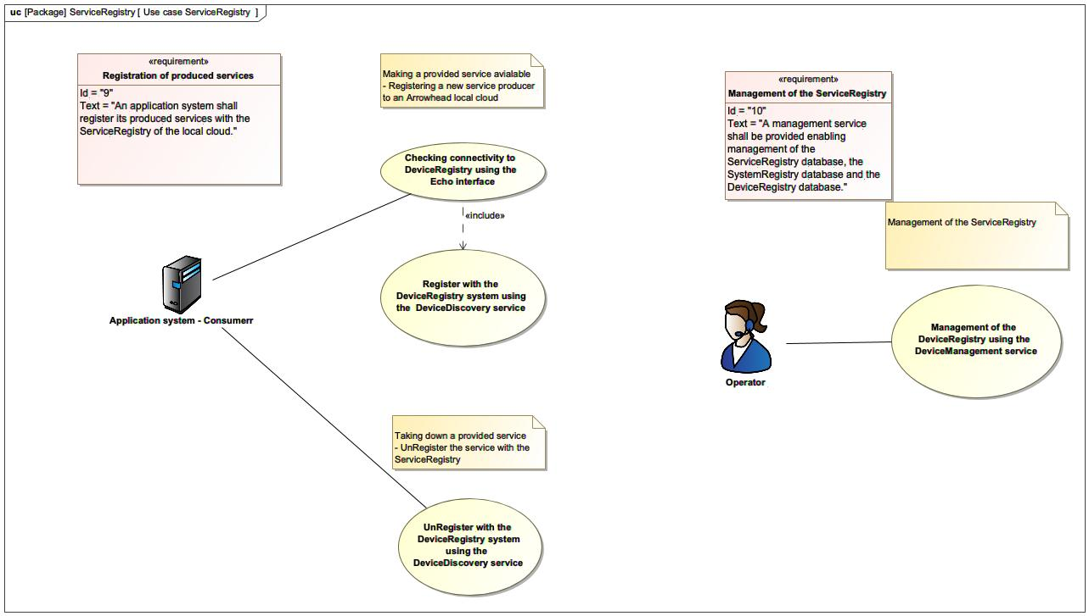

1. Use case ServiceRegistry

## Use cases Authorisation

NA

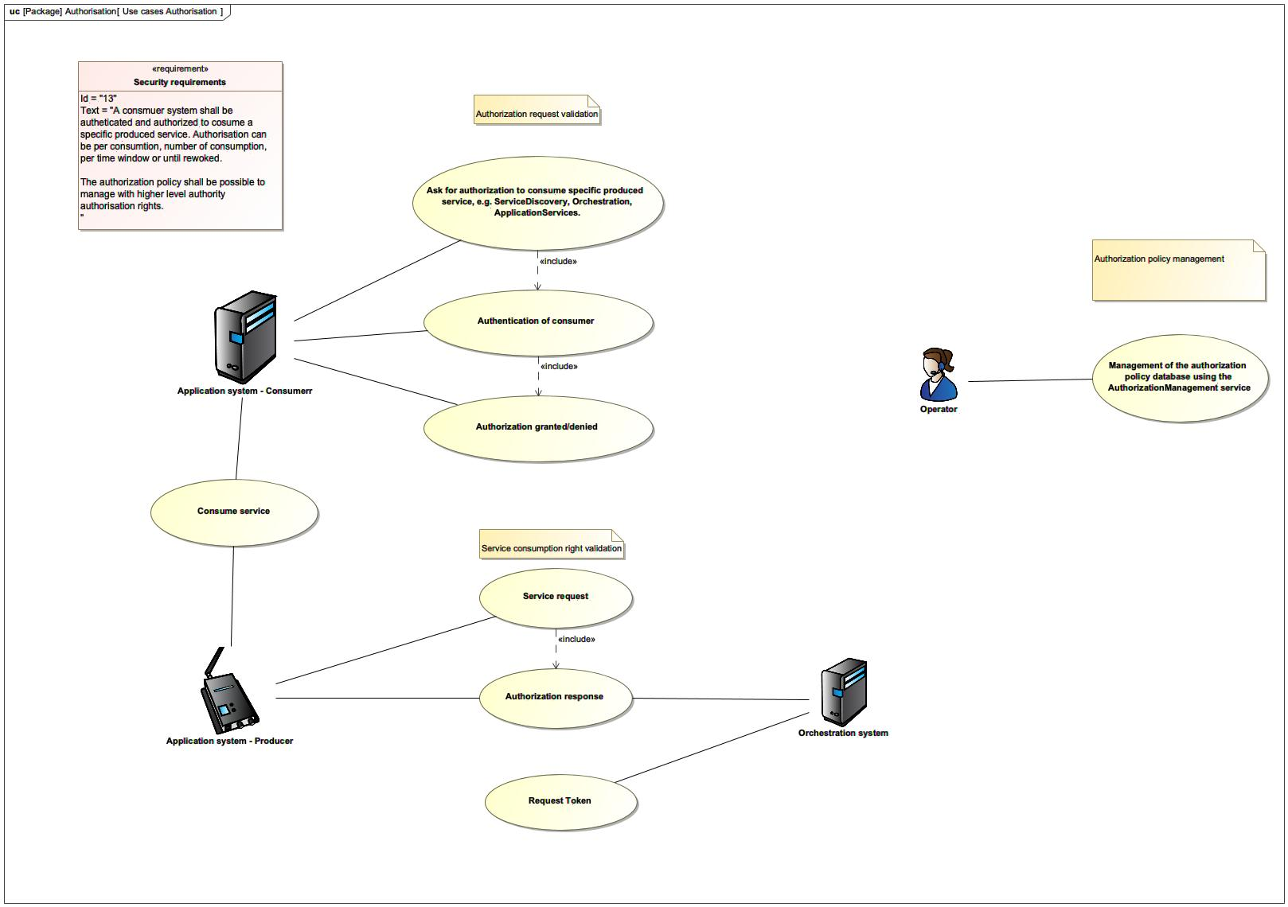

1. Use cases Authorisation

## Use-case-SystemRegistry

NA

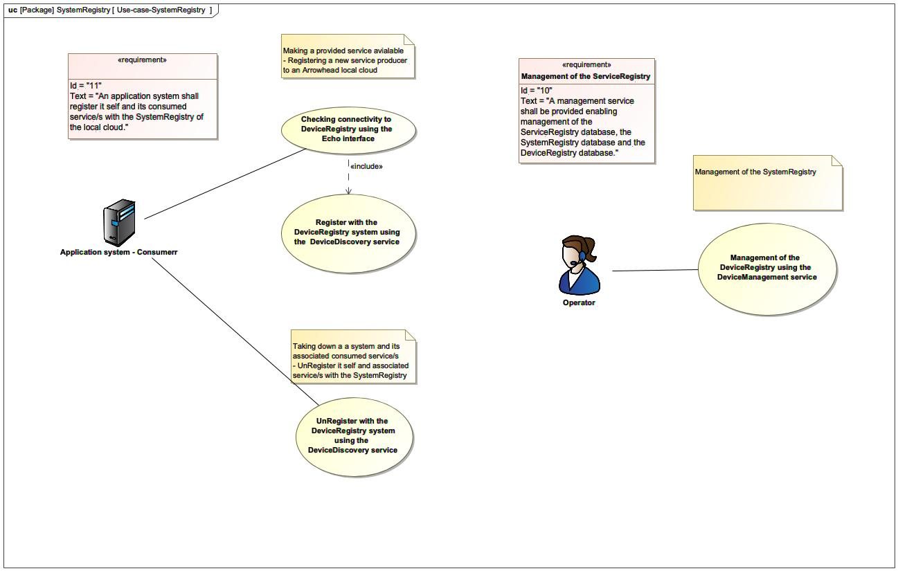

1. Use-case-SystemRegistry